**Year 7 Transition Days Thursday 3rd July and Friday 4th July 2025**

Dear Parent/Carer,

We’re excited to welcome your child to All Saints’ Academy next week for our two-day Year 7 Transition Induction.

Over the two days, students will take part in a variety of engaging lessons and activities designed to give them a taste of secondary school life. They’ll also meet their Year 7 Progress Leader, Mrs N Mitchell, and get to know some of their future teachers.

Key Information

Dates: Thursday 3rd & Friday 4th July 2025

Arrival Time: 8:30 am at the main entrance

Collection Time: 3:15 pm from outside Cotswold Hall

Dress Code: Primary school uniform with trainers (in a bag) for sports activities

Meals: A hot lunch, cake, and a drink will be provided each day. Students may also bring their own packed lunch, snacks, and drinks if preferred. Please ensure your child brings a water bottle to stay hydrated.

If you would like your child to walk home with an older sibling, please email your consent in advance.

Induction Information Evening

We also invite you to our Induction Information Evening on Thursday 3rd July, 6:00–7:00 pm in Cotswold Hall. This is a great opportunity to meet Mrs Mitchell and ask any questions you may have about the transition to secondary school.

If you have any questions, feel free to contact me or Mrs Mitchell at NMitchell@asachelt.org.

We look forward to welcoming our new Year 7 students!

Yours faithfully

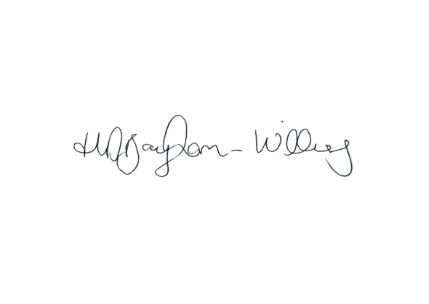

Miss H Baynham-Williams

Head of Transition

HBaynhamWilliams@asachelt.org