**Year 7 Transition 2025**

Dear Parents and Carers,

I hope this letter finds you and your family in good health. As we embark on your child’s exciting transition journey, I want to share some key notices with you to support you in taking the next steps in joining our Academy family.

Congratulations and welcome to All Saints’ Academy!

Firstly, let me introduce two key figures who will help to provide a seamless transition from primary to secondary school:

Mr B Williams Miss H Baynham-Williams

Principal Head of Transition

Please make a note of these key diary dates to help you plan for a successful transition:

|  |  |
| --- | --- |
| **Week commencing Monday 17th March** | Parent Welcome Letter and Student Postcard received in the post |
| **Monday 17th March** | Offer acceptance deadline |
| **Throughout April/ May** | Year 6 school visits from Miss H Baynham-Williams and Mrs L Herrick (SENDCo) |
| **Friday 23rd May** | ASA Pen Pal letters delivered to Primary Schools |
| **Thursday 3rd July – Friday 4th July** | Transition Days at All Saints’ Academy |
| **Evening of Thursday 3rd July** | New Year 7 Parents Information Evening |
| **Monday 18th August – Friday 22nd August** | Transition Summer School |
| **Wednesday 3rd September** | First day at All Saints’ Academy *(Year 7 & 12 only)* |

I look forward to coming to your child’s school to meet them in person soon and can’t wait to welcome you to All Saints’ Academy.

Yours sincerely,

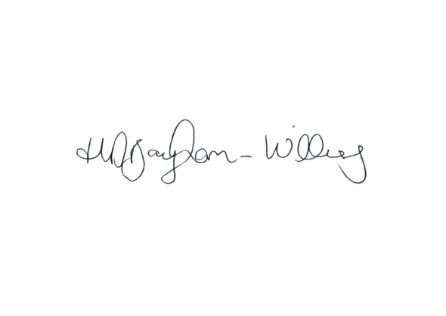

Miss H Baynham-Williams

Head of Transition

HBaynhamWilliams@asachelt.org