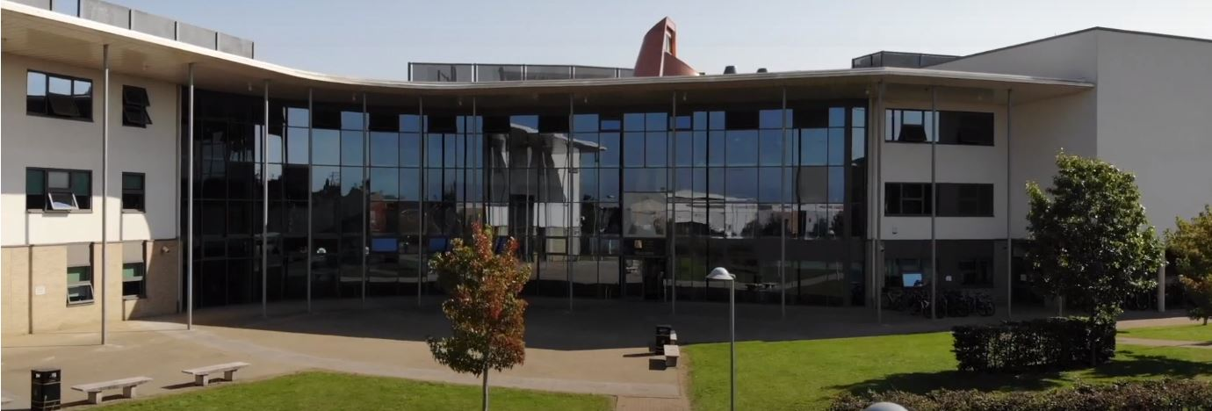
Application Pack
Teacher of Design and Technology
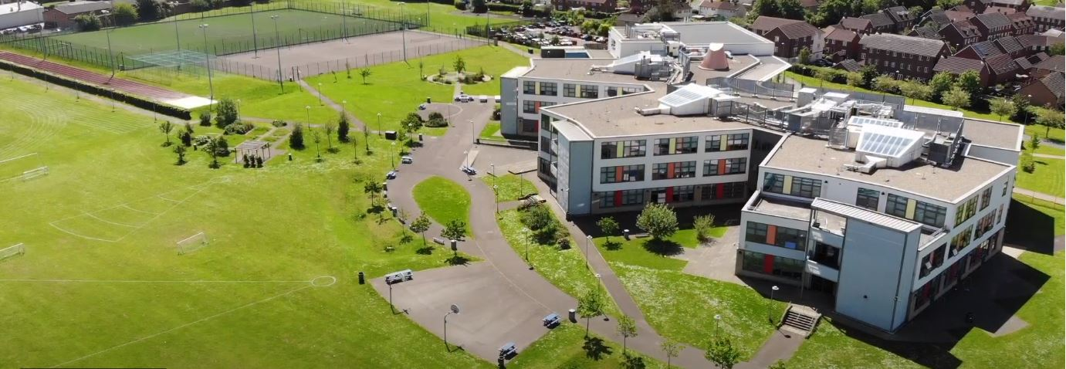
Where every member of our extended family realises their God-given potential, inspired by John 10:10. Jesus said ‘I have come so you may have life in all its fullness’.
2014 2018

www.asachelt.org

All Saints’ Academy, Cheltenham, Gloucestershire.
Principal: Mr Dermot McNiffe

Teacher of Design and Technology
Start date: 1st September 2023 or 1st January 2024
Salary: Academy Main Scale/ Upper Pay Scale £28,000 - £43,685 pro-rata
Hours of work: Full Time
Contract: Permanent
Closing date: 9.00am, Tuesday 20th June 2023

We wish to appoint an outstanding Teacher of Design and Technology to join the Art and Design Faculty at All Saints’ Academy. The Academy currently provides D&T courses in Product Design and Construction.
The appointed candidate will work closely with the Head of Faculty to ensure the academic quality of the subject’s courses and maintain strong student progress and outcomes for all.

Applications are invited from NQTs and experienced teachers.
All Saints’ Academy is one of the best GCSE performing non-selective secondary schools in the Cheltenham and Tewkesbury area, and it has been for a number of years now.

Following another Good judgement, Ofsted reported:

• All Saints’ Academy is an inclusive school.
• Leaders and directors have been successful in improving pupils’ life chances by ensuring that they have achieved well in recent years.
• Staff hold fast to the school’s values and ethos, which unite them in their drive to improve standards.
• There is a clear determination to support pupils and their families to overcome barriers.
Ofsted 2018

Sponsored by the Anglican Diocese of Gloucester, we are an Academy serving at the heart of our local community. All Saints’ Academy has a Life Vision, ‘Where every member of our extended family realises their God-given potential, inspired by John 10:10. Jesus said 'I have come so you may have life in all its fullness'.

We are an inclusive Church Academy who welcomes applications from all denominations and those of none.

What we offer:
- The Academy is in an attractive new building, within easy access to Cheltenham, Tewkesbury and the M5 with onsite catering facilities
- Entry into the Teachers’ Pension scheme
- Free access to the onsite gym facility
- Access to our Employee Assistance Scheme
- Free onsite parking including electric car charge points

The Academy is committed to safeguarding and promoting the welfare of children and young people, and expects all staff and volunteers to share this commitment. Shortlisted candidates will be subject to an online search in line with Keeping Children Safe in Education 2022 recommendations. Successful applicants will be subject to enhanced DBS clearance.

To apply for this role please complete an online application form that can be found on the Academy website www.asachelt.org If you have any questions regarding this role please contact Katie Jordan, HR Manager at hr@asachelt.org

All Saints’ Academy is committed to ensure that all applicants and employees are given equal opportunities and that no applicants or employees are discriminated against on the basis of gender, gender reassignment, race, disability, pregnancy or maternity, sexual orientation, marital or civil partnership status, age or religion and belief.

Job Description

Post Title: Teacher

Salary: Academy Main Pay Scale Points 1-12/ Upper Pay scale 1-3

This Academy is committed to safeguarding and promoting the welfare of children and young people and requires all staff to share this commitment

Core Purpose:

Work with the Head of Faculty and other staff to devise and implement a range of strategies that will lead to high quality teaching and raise attainment.

Take an active role to realise the vision for the Academy.

Deliver education, care and support that ensure the whole child is supported, achieves, develops and succeeds.

Proactively support the activities and nature of a Church Academy with its Christian distinctiveness.

Reporting To: Head of Faculty/ Head of Department

Core Duties (as set out in Teacher Standards)
Set high expectations which inspire, motivate and challenge students
- Establish a safe and stimulating environment for students, rooted in mutual respect
- Set goals that stretch and challenge students of all backgrounds, abilities and dispositions
- Demonstrate consistently the positive attitudes, values and behaviour which are expected of students
- Communicate with students, parents and carers in accordance with the Academy ethos, policies and practice.

Promote good progress and outcomes by students
- Be accountable for students’ attainment, progress and outcomes
- Be aware of students’ capabilities and their prior knowledge, and plan teaching to build on these
- Guide students to reflect on the progress they have made and their emerging needs
- Demonstrate knowledge and understanding of how students learn and how this impacts on teaching
- Encourage students to take a responsible and conscientious attitude to their own work and study
- Contribute to the development, implementation and evaluation of the Academy policies, practices and procedures in such a way as to support the Academy’s values and vision
- Work with others on curriculum and/or student development to secure co-ordinated outcomes

Demonstrate good subject and curriculum knowledge
- Have a secure knowledge of the relevant subject(s) and curriculum areas, foster and maintain students’ interest in the subject, and address misunderstandings
- Demonstrate a critical understanding of developments in the subject and curriculum areas, and promote the value of scholarship
- Demonstrate an understanding of and take responsibility for promoting high standards of literacy, articulacy and the correct use of standard English, whatever the teacher’s specialist subject

Plan and teach well-structured lessons
- Impart knowledge and develop understanding through effective use of lesson time
- Promote a love of learning and children’s intellectual curiosity
- Set and assess Independent Learning Tasks and plan other out-of-class activities to consolidate and extend the knowledge and understanding students have acquired
- Reflect systematically on the effectiveness of lessons and approaches to teaching
- Contribute to the design and provision of an engaging curriculum within the relevant subject area
- Participate in arrangements for preparing students for external examinations

Adapt teaching to respond to the strengths and needs of all students
- Know when and how to differentiate appropriately, using approaches which enable students to be taught effectively
- Have a secure understanding of how a range of factors can inhibit students’ ability to learn, and how best to overcome these
- Demonstrate an awareness of the physical, social and intellectual development of children, and know how to adapt teaching to support students’ education at different stages of development.
- Have a clear understanding of the needs of all students, including those with special educational needs; those of high ability; those with English as an additional language; those with disabilities; and be able to use and evaluate distinctive teaching approaches to engage and support them.

Make accurate and productive use of assessment
- Know and understand how to assess the relevant subject and curriculum areas, including statutory assessment requirements
- Make use of formative and summative assessment to secure students’ progress
- Use relevant data to monitor progress, set targets, and plan subsequent lessons
- Give students regular feedback, both orally and through accurate marking, and encourage students to respond to the feedback

Manage behaviour effectively to ensure a good and safe learning environment
- Have clear rules and routines for behaviour in classrooms, and take responsibility for promoting good and courteous behaviour both in classrooms and around the Academy, in accordance with the Academy’s behaviour policy.
- Have high expectations of behaviour, and establish a framework for discipline with a range of strategies, using praise, sanctions and rewards consistently and fairly.
- Manage classes effectively, using approaches which are appropriate to students; needs in order to involve and motivate them
- Maintain good relationships with students, exercise appropriate authority, and act decisively when necessary
- Promote the safety and well-being of students in accordance with the Academy’s Child Protection and other relevant policies

Fulfil wider professional responsibilities
- Make a positive contribution to the wider life and ethos of the Academy
- Develop effective professional relationships with colleagues, knowing how and when to draw on advice and specialist support
- Deploy support staff effectively
- Take responsibility for improving teaching through appropriate professional development, responding to advice and feedback from colleagues
- Communicate effectively with parents with regard to students’ achievements and well-being
- Direct and supervise support staff assigned to you and, when appropriate, other teachers.
- Contribute to the recruitment, selection, appointment and professional development of other teachers and support staff
- Deploy resources delegated to you in accordance with Academy policies
- Participate in arrangements for the appraisal and review of your own performance and, where appropriate, that of other teachers and support staff
- Participate in arrangements for your own further training and professional development and, where appropriate, that of other teachers and support staff including Induction.

PERSON SPECIFICATION

Teacher of Design and Technology

 | Essential | Desirable
Qualifications | - Graduate with good degree in a relevant subject.  - Qualified Teaching Status. | - Further professional qualifications in the subject field of Design and Technology plus other Teaching and Learning CPD.
Skills | - Excellent teaching skills.  - Ability to teach Design and Technology at GCSE and A level  - Ability to offer extra-curricular activities.  - Able to inspire, lead and support young people.  - Show initiative and approach challenges with a positive attitude.  - Able to use data effectively to assess prior attainment, track progress and set student targets. | - Ability to use technology as a learning and teaching tool and a motivator.  - Knowledge of examination specifications and requirements for Design and Technology.  - Specialism in Engineering or construction and ability to teach to Key stage 4 and 5
General | - Flexible and enthusiastic attitude.  - Clear ability to relate to young people.  - A commitment to a positive culture of learning.  - Resilience to support and find ways to develop young people.  - Excellent communication skills.  - Experience of planning successful lessons.  - Clearly able to demonstrate the standards relevant to experience in teaching. | - Have ideas that you can turn into practice.  - Ability to work proactively in a team.  - Ability to self-review effectively and set appropriate performance targets.  - Willingness to organise and participate in school trips.  - Willingness to organise and participate in extracurricular activities.

