Application Pack
Teaching Assistant
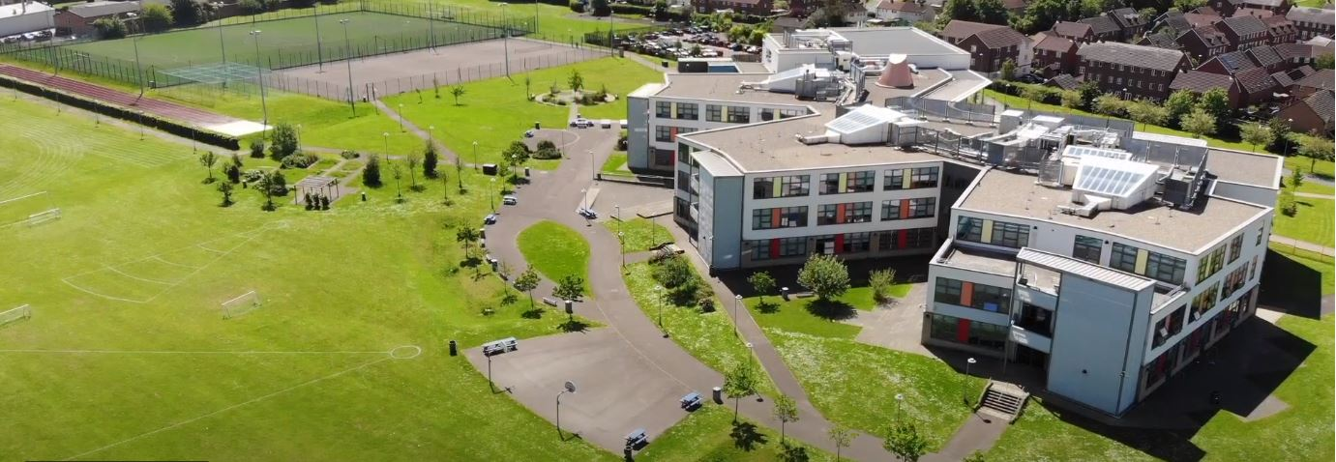
Where every member of our extended family realises their God-given potential, inspired by John 10:10. Jesus said ‘I have come so you may have life in all its fullness’.
2014 2018

www.asachelt.org

All Saints’ Academy, Cheltenham, Gloucestershire.
Principal: Mr Dermot McNiffe

Teaching Assistant
Start date: 1st September 2023
Salary: Grade 4 Points 7-10 £22,396 - £23,620 pro-rata
Hours of work: 30 hours per week/ Term Time plus one week for Inset days
Contract: Permanent
Closing Date: 9am Tuesday 20th June 2023

We are seeking to appoint a skilled, enthusiastic and creative Teaching Assistant to support student learning. Previous experience supporting students with a variety of learning needs would be an advantage but not necessary.

The hours of work will be 8.30 am to 3.20 pm Monday to Friday. Further part time hours will be considered.
Our second Good Ofsted judgement reported:

• All Saints’ Academy is an inclusive school.
• Leaders and directors have been successful in improving pupils’ life chances by ensuring that they have achieved well in recent years.
• Staff hold fast to the school’s values and ethos, which unite them in their drive to improve standards.
• There is a clear determination to support pupils and their families to overcome barriers.
Ofsted 2018

Sponsored by the Anglican Diocese of Gloucester, we are an Academy serving at the heart of our local community. All Saints’ Academy has a Life Vision, ‘Where every member of our extended family realises their God-given potential, inspired by John 10:10. Jesus said 'I have come so you may have life in all its fullness'.

We are an inclusive Church Academy who welcomes applications from all denominations and those of none.

What we offer:

- The Academy is in an attractive new building, within easy access to Cheltenham, Tewkesbury and the M5 with onsite catering facilities
- Entry into the Local Government Pension scheme
- Free access to the onsite gym facility
- Access to our Employee Assistance Scheme
- Free onsite parking including Electric car charge points

The Academy is committed to safeguarding and promoting the welfare of children and young people, and expects all staff and volunteers to share this commitment. Shortlisted candidates will be subject to an online search in line with Keeping Children Safe in Education 2022 recommendations. Successful applicants will be subject to enhanced DBS clearance.

To apply for this role please complete an online application form through the Academy website www.asachelt.org If you have any questions regarding this vacancy please contact Mrs Katie Jordan, HR Manager at hr@asachelt.org

All Saints’ Academy is committed to ensure that all applicants and employees are given equal opportunities and that no applicants or employees are discriminated against on the basis of gender, gender reassignment, race, disability, pregnancy or maternity, sexual orientation, marital or civil partnership status, age or religion and belief.

Job Description

Post Title: Teaching Assistant

Reporting To: Heads of Department/Leader of Learning Support

Key Activities
To aid pupils to learn as effectively as possible both in group situations and on his/her own by, for example:

  - Clarifying and explaining instructions.
  - Motivating and encouraging the students as required by providing levels of individual attention, reassurance and help with learning tasks as appropriate to students’ needs.
  - Assisting in weaker areas, e.g. speech and language, behaviour, reading, spelling, numeracy, handwriting/presentation etc.
  - Using praise, commentary and assistance to encourage the students to concentrate and stay on task
  - Being aware of Individual Learning Plans for students in the groups.
  - Providing additional nurture to individuals when requested by the class teacher.
  - Helping to make appropriate resources to support the students.

Apply the Academy’s behaviour and standards policies and report any difficulties via the established procedure.

Be responsible for displays of students work in Academy.

Liaise regularly with the teacher and/or take part in planning meetings, inset days and any other meetings as required

Build positive relationships with both students and staff.

To take part in enrichment and specialism activities, as may be required.

To promote the acceptance and inclusion of all students, encouraging students to interact with each other in an appropriate and acceptable manner.

Monitor the student’s response to the learning activities and, where appropriate, modify or adapt the activities as agreed with the teacher to achieve the intended learning outcomes.

Give the students feedback on achievements in order to reinforce and develop self-reliance and self-esteem, including marking student’s work.

To support the students in developing social skills both in and out of the Classroom.

To support the use of ICT in learning activities

To provide regular feedback on the students’ learning and behaviour to the teacher.

When working with a group of students, understand and use group dynamics to promote group effectiveness and support group and individual performance.

To use the Academy’s system for recording data as requested by the teacher.

To prepare work and activities in advance of the lesson (within employed hours)

Undertake social time supervision including after school clubs if requested

Accompany teacher and students on educational visits

To attend Academy/department meetings to contribute to the discussions about individual students as required.

Invigilate internal and external examinations when required.

Accountability
Ensure appropriate support to staff and students is provided.

Be aware of and comply with policies and procedures relating to child protection, health and safety, security, confidentiality and data protection. Reporting all concerns to the appropriate person.
Other Specific Duties

All support staff will be expected to accept reasonable flexibility in working arrangements and the allocation of duties, in pursuance of raising student achievement and effective team working. Support Staff will also:

- model the ethos and vision for the Academy
- to continue personal professional development as required
- to actively engage in the performance review process
- support whole Academy acts of worship and prayer for the day.

It is important that all staff recognise that they are an integral part of the Academy and have a duty to contribute to its overall effectiveness both within their specific areas and beyond.

It is the vision of the Academy to involve all support staff in the life of the Academy and in particular in supporting students as House Tutors, Mentors and other appropriate ways.

Whilst every effort has been made to explain the main duties and responsibilities of the post, each individual task may not be identified. Employees will be expected to comply with any reasonable request from the Principal to undertake work of a similar level that is not specified in this job description and to undertake all duties reasonably requested by their line manager in a manner consistent with the vision of All Saints’ Academy.

The academy will endeavour to make any necessary reasonable adjustments to the job and the working environment to enable access to employment opportunities for disabled job applicants or continued employment for any employee who develops a disabling condition.

Person specification

Teaching Assistant

 | Essential | Desirable
Qualifications | - English and Maths GCSE Grade C/ Level 4 or above | - Level 3 qualification relevant to Supporting Children in the Classroom  - Safeguarding Training
Skills | - Ability to remain calm and patient in a variety of classroom and learning situations.  - Previous experience of working with young people in a learning environment or experience of delivering 1:1/small group interventions.  - Able to inspire and support young people.  - Show initiative and approach challenges with a positive attitude.  - Able to use data effectively to assess prior attainment and track progress. | - Working knowledge of phonetic approaches to reading.  - Use of SIMS as a data recording system would be useful.
General | - Flexible and enthusiastic attitude  - Clear ability to relate to young people.  - A commitment to a positive culture of learning.  - Resilience to support and find ways to develop young people.  - Excellent communication skills. | - Have ideas that you can turn into practice.  - Ability to be part of a team  - Ability to self-review effectively and set appropriate targets.  - Willingness to participate in school trips

