Positive Mental Health and Wellbeing Policy

Linked policies: Safeguarding and Child Protection Policy, Medical Conditions & Managing Medicines Policy, Special Educational Needs & Disability (SEND) Policy

Introduction:
The polices of All Saints’ Academy, with its distinctive Anglican and Catholic foundations, exist to support the Sponsor’s vision, Christian ethos and values that are embedded in the day-to-day and long-term running of the Academy. Each policy evidences the commitment of the Sponsor to developing Body, Mind and Spirit.

This policy should be read in conjunction with our medical policy in cases where a student’s mental health overlaps with or is linked to a medical issue and the SEN or disability policy where a student has an identified special educational need.

Why Mental Health and Wellbeing is Important

We aim to promote positive mental health and wellbeing for our whole school community; students, staff, parents and carers, and recognise how important mental health and emotional wellbeing is to our lives in just the same way as physical health.

We recognise that young people’s mental health is a crucial factor in their overall wellbeing and can affect their learning and achievement. Persistent mental health problems may lead to students having significantly greater difficulty in learning than the majority of those of the same age.

The Special Educational Needs and Disabilities (SEND) Code of Practice identifies Social, Emotional and Mental Health as one of the four areas of Special Educational Need.

All young people go through ups and downs through their school career and some face significant life events and adverse childhood experiences.

The Department for Education (DfE) recognises that: “in order to help their students succeed; schools have a role to play in supporting them to be resilient and mentally healthy”.

Schools can be a place for young people to experience a nurturing and supportive environment that has the potential to develop self-esteem and give positive experiences for overcoming adversity and building resilience. For some, school will be a place of respite from difficult home lives and offer positive role models and relationships, which are critical in promoting students’ wellbeing and can help engender a sense of belonging and community.

Our role is to ensure that our students are able to manage times of change and stress, to be resilient, and that they are supported to reach their potential and access help when they need it. We also have a role to play in ensuring that students learn about what they can do to maintain positive mental health, what affects their mental health, how they can help reduce the stigma surrounding mental health issues and where they can go if they need help and support.

Our aim is to help develop the protective factors which build resilience to mental health problems and be a school where
- all students are valued
- students have a sense of belonging and feel safe
- students feel able to talk openly with trusted adults about their problems without feeling any stigma
- positive mental health is promoted and valued
- bullying is not tolerated

In addition to young people’s wellbeing, we recognise the importance of promoting staff mental health and wellbeing.

Purpose of the Policy

This policy sets out
- how we promote positive mental health
- how we prevent mental health problems
- how we identify and support students with mental health needs
- how we train and support all staff to understand mental health issues and spot early warning signs to help prevent mental health problems getting worse
- key information about some common mental health problems
- where parents, staff and students can get advice and support

Definition of Mental Health and Wellbeing

We use the World Health Organisation’s definition of mental health and wellbeing:

… a state of wellbeing in which every individual realises his or her own potential, can cope with the normal stresses of life, can work productively and fruitfully, and is able to make a contribution to her or his community.

Mental health and wellbeing is not just the absence of mental health problems. We want all young people to:

- feel confident in themselves
- be able to express a range of emotions appropriately
- be able to make and maintain positive relationships with others
- cope with the stresses of everyday life
- manage times of stress and be able to deal with change
- learn and achieve

4. A Whole School Approach to Promoting Positive Mental Health

We take a whole school approach to promoting positive mental health that aims to help students to become more resilient, to be happy and successful and to prevent problems before they arise.

This encompasses seven aspects:

- creating an ethos, policies and behaviours that support mental health and resilience that everyone understands
- helping students to develop social relationships, to support each other and to seek help when they need it
- helping students to be resilient learners
- teaching students social and emotional skills and an awareness of mental health
- early identification of students who have mental health needs and planning support to meet their needs, including working with specialist services
- effectively working with parents and carers
- supporting and training staff to develop their skills and resilience

We also recognise the role that stigma can play in preventing understanding and awareness of mental health issues and aim to create an open and positive culture that encourages discussion and understanding of mental health issues.

Supporting Students’ Positive Mental Health

Schools have a key role in promoting students’ positive mental health and helping to prevent mental health problems. We have developed a range of strategies and approaches including;

Student-led Activities
  - Campaigns and assemblies to raise awareness of mental health
  - Student voice
Transition Support
  - Support for vulnerable young people through the transition process
  - Transition meetings with parent/carers, students and relevant staff
  - Sharing of information between primary settings and the Academy
  - Key adults support secondary school visits with vulnerable students

Whole School
  - Wellbeing Focus
  - Assembly themes
  - Displays and information around the school about positive mental health and where to go for help and support.

Small Group Activities
  - Social skills
  - ELSA
  - Solution focused approaches
  - Peer support through extracurricular clubs and groups
  - Mentoring – both on and off site

Teaching about Mental Health and Emotional Wellbeing
  - Through PSHE we teach the knowledge and social and emotional skills that will help students to be more resilient, to understand mental health and to help reduce the stigma of mental health problems.

Our approach is to:
  - provide a safe environment to enable students to express themselves and to be listened to
  - ensure the welfare and safety of students
  - identify appropriate support for students based on their needs
  - involve parents and carers when their child needs support
  - involve students in the care and support they receive
  - assess, plan, implement and review the support with students, parents and carers

7. Identification of need

See Appendix 1 – Graduated Response for Mental Health and Wellbeing.

Our identification system involves a range of processes. We aim to identify young people with mental health and emotional wellbeing needs as early as possible to prevent things getting worse.

We do this in different ways including:

  - Analysing behaviour, suspensions, visits to the medical room, attendance and punctuality
  - Staff reporting concerns about individual students to pastoral staff and the Designated Safeguarding Team
  - Sharing information about support approaches for individual students about whom we are concerned in weekly all staff briefings
  - Holding a weekly Vulnerable Students Panel in which key staff discuss concerns
  - Gathering information from previous schools at transfer or transition
  - Arranging induction meetings for students joining part way through the year
  - Meeting with parents and carers
  - Enabling students to raise concerns
  - Enabling parents and carers to raise concerns

Signs that a student may be in need of further support include

  - Expressing that they feel low, unhappy or in need of help
  - Recent changes in behaviour
  - Becoming socially withdrawn at home or in school
  - Changes in activity, mood, eating or sleeping habits
  - Declining academic achievement
  - Not wanting to be in lessons
  - Disclosing self-harm
  - Talking or joking about self-harm or suicide
  - Expressing feelings of failure, uselessness or loss of hope
  - An increase in lateness or reduced attendance
  - Not wanting to do PE or get changed for PE
  - Wearing long sleeves in hot weather
  - Drug or alcohol misuse
  - Physical signs of harm that are repeated or appear non-accidental
  - Repeated physical pain or nausea with no evident cause

If there is a concern that a student is in danger of immediate harm then the school’s child protection procedures are followed.

Disclosures by Students

We recognise how important it is that staff are calm, supportive, and non-judgmental if a student discloses a concern about themselves or a peer. The emotional and physical safety of students is paramount, and staff listen rather than advise. In accordance with safeguarding training, staff explain to students that the concern will be shared with the Designated Safeguarding Team and recorded to provide appropriate support to the student.

Disclosures and all subsequent actions are recorded on the Academy’s safeguarding recording system (CPOMS).

Assessment, Interventions and Support

All concerns are reported to pastoral staff or the Designated Safeguarding Team and recorded on CPOMS where appropriate. We then implement our assessment system based on our Graduated Response and Continuum of Need to ensure that students get the support they need, either from within the school or from an external specialist service. Our aim is to put in place interventions as early as possible to prevent problems escalating.

8. Working with external agencies

See Appendix 2 – Continuum of Need.

In some cases a student’s mental health needs require support from a specialist service.

We work in partnership with various outside agencies that help us to identify and implement the right level of support for students in any given circumstances.

Referrals to a specialist service will be made by the Academy staff following the assessment process and in consultation with the student and their parents and carers.

9. Involving Parents and Carers

Promoting Mental Health
We recognise the important role parents and carers have in promoting and supporting the mental health and wellbeing of their young people, and in particular supporting their young people with mental health needs.

To support parents and carers:
- we arrange several Mental Health workshops throughout the year, drawing in expertise from other agencies such as Children and Adolescent Mental Health Services, Young Minds Matter, TiC+ and the School Nursing Service.
- we provide information and signposting to organisations for support with mental health issues and local wellbeing and parenting support programmes.

When a concern has been raised the school will:
- follow the process set out in our Graduated Response (see Appendix 1), informed by our Continuum of Need.
- in most cases parents and carers will be involved in planning their young people’s interventions, although there may be circumstances when this may not be appropriate.
- provide information and resources for further information
- keep parents and carers up to date and fully informed of decisions about the support and interventions implemented where appropriate

Parents and carers will always be informed if their child is at risk of danger.

We make every effort to support parents and carers to access services where appropriate. Students are our primary concern, and in the rare event that parents and carers are not supporting their young person to access support, we will seek advice from the Local Authority.

We are able to provide information for parents and carers to access support for their own mental health needs.

10. Involving Students
- should a student need support with their mental health and emotional wellbeing, they will always be included in planning for this in a way that they are comfortable with.
- we seek students’ views and feedback about our approach and whole school mental health activities through Student Voice, surveys, class questions and suggestion boxes

11. Supporting and Training Staff
We want all staff to be confident in their knowledge of mental health and wellbeing and to be able to promote positive mental health and wellbeing, to identify mental health needs early in students and to know what to do and where to get help.
Those staff with a specific responsibility have more specialised training and where possible access to supervision from mental health professionals.

Supporting and promoting the mental health and wellbeing of staff is an essential component of a healthy school and we promote opportunities to maintain a healthy work life balance and wellbeing.

Staff have access to SmartClinic and Health Assured Employee Assistance.

SmartClinic: 0800 862 0142
Health Assured EAP: 0800 028 0199

12. Monitoring and Evaluation
The effectiveness of this policy will be monitored by pastoral staff, the Designated Safeguarding Team and the Senior Leadership Team and feedback will be provided to the appropriate trustees’ committee. This policy will be reviewed every three years or sooner if deemed necessary.

Appendix 1.

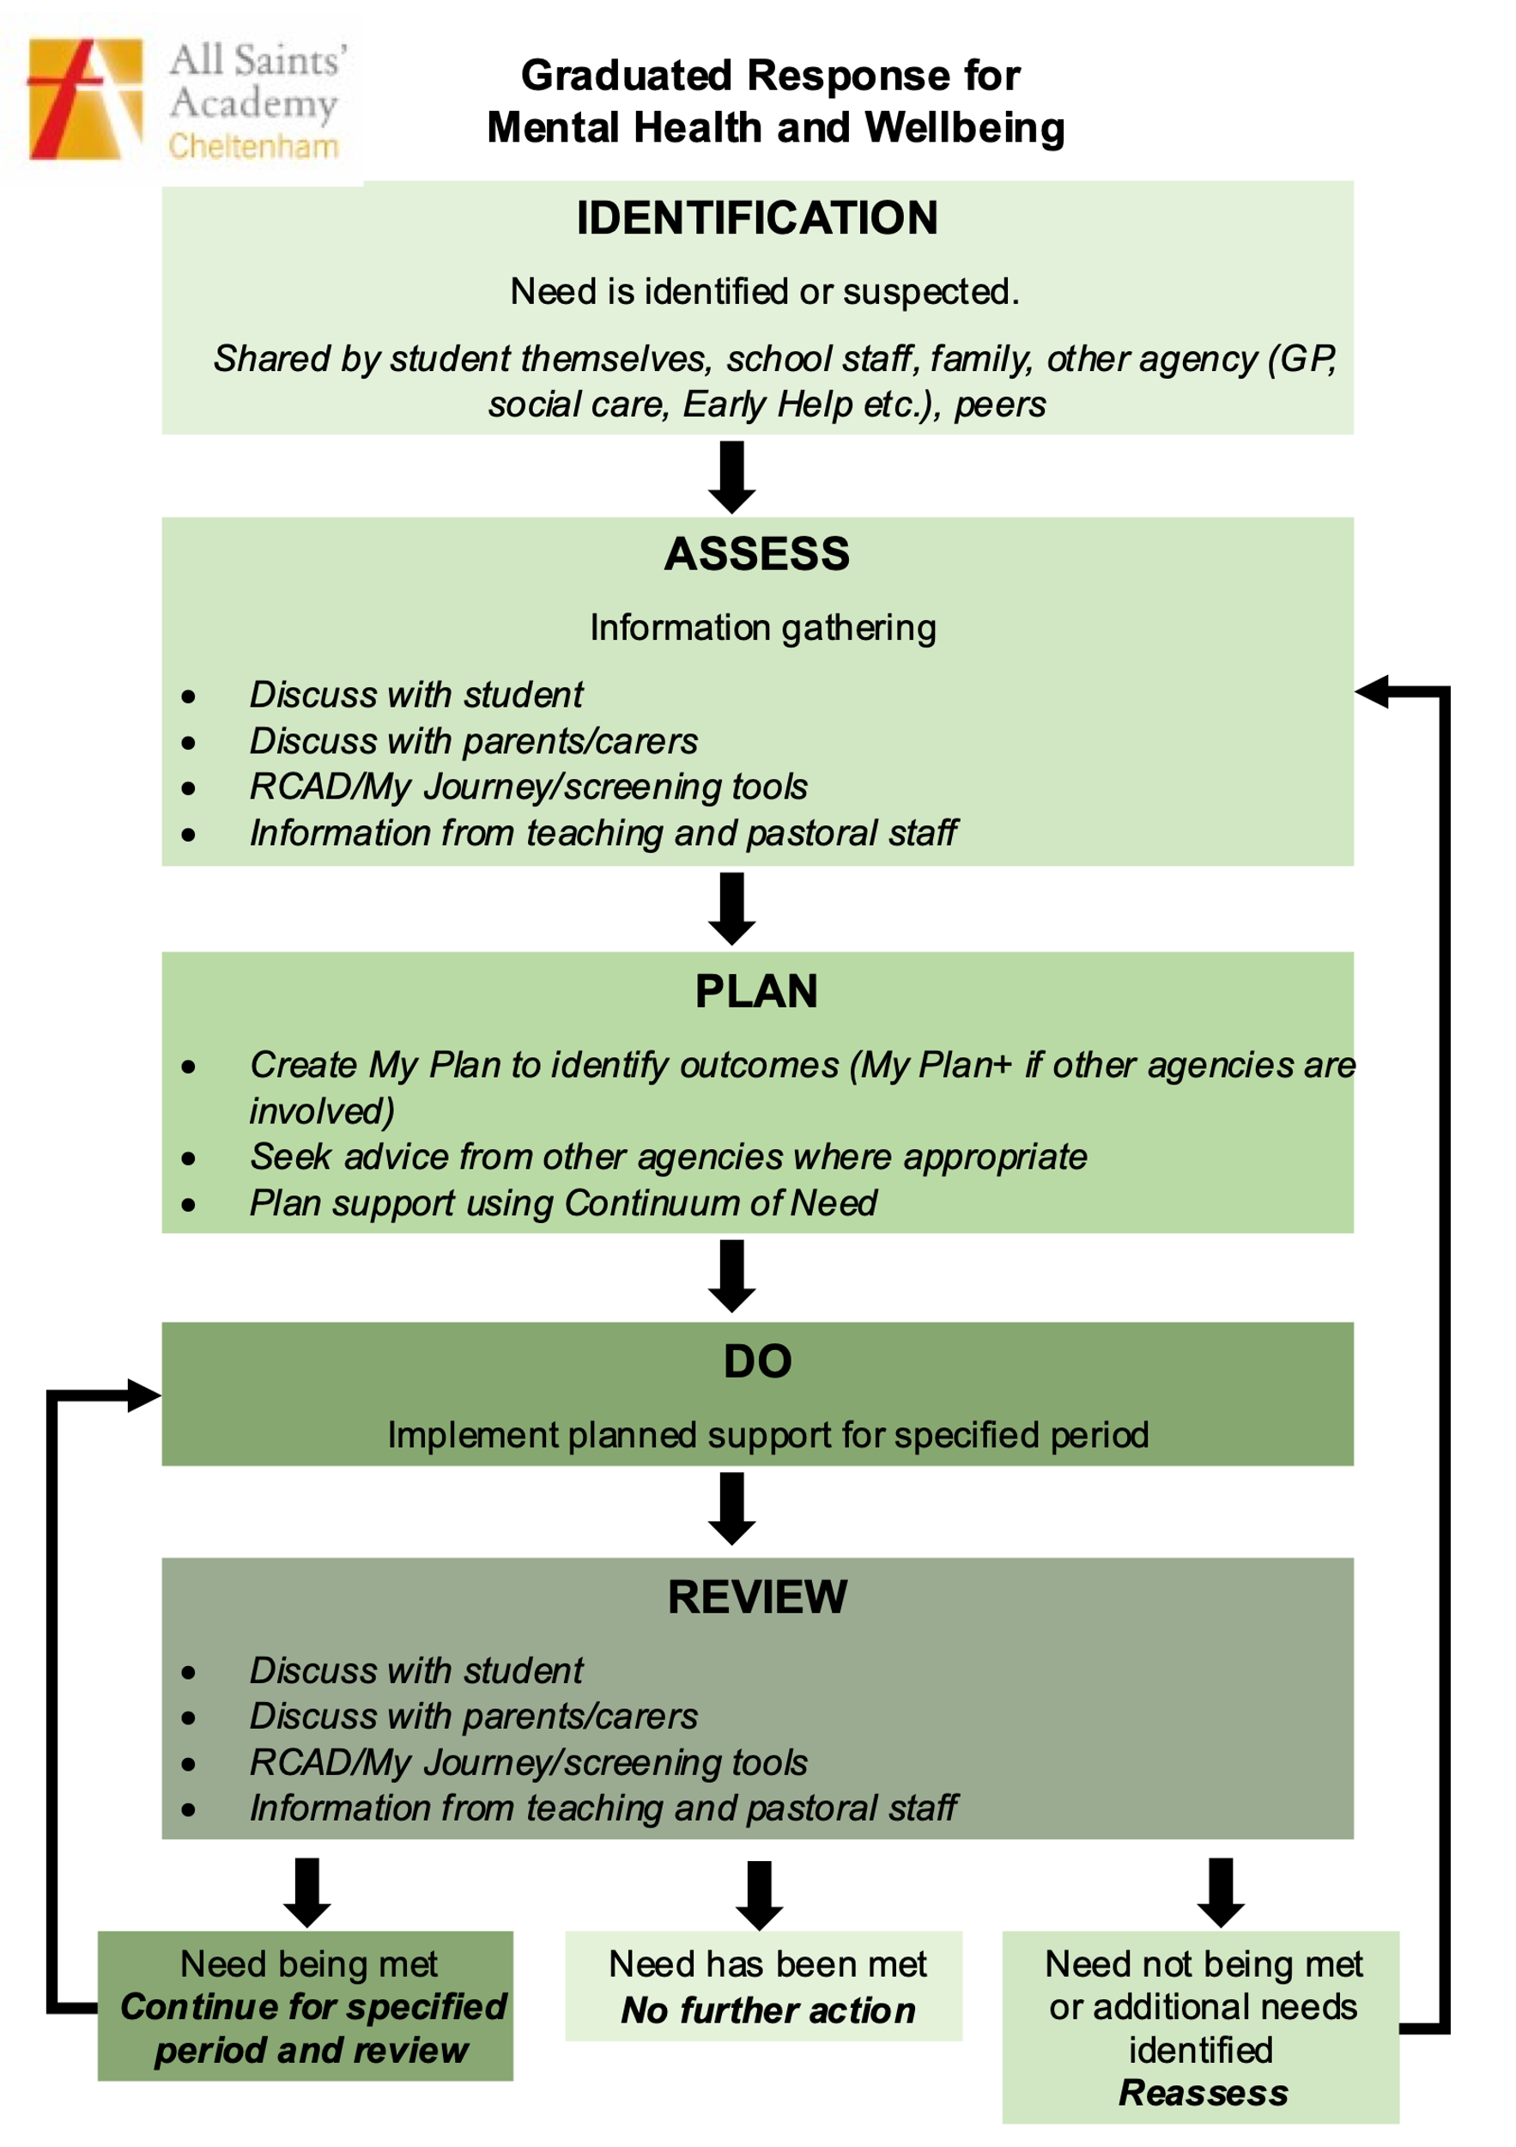

Appendix 2.

Sources of information and support
For support on specific mental health needs

Anxiety UK www.anxietyuk.org.uk
OCD UK www.ocduk.org
Depression Alliance www.depressoinalliance.org
Eating Disorders www.b-eat.co.uk and www.inourhands.com
National Self-Harm Network www.nshn.co.uk
Self-Harm www.selfharm.co.uk
Suicidal thoughts Prevention of young suicide UK – PAPYRUS: www.papyrus-uk.org

For general information and support
www.youngminds.org.uk champions young people’s mental health and wellbeing www.mind.org.uk advice and support on mental health problems
www.minded.org.uk (e-learning)
www.time-to-change.org.uk tackles the stigma of mental health www.rethink.org challenges attitudes towards mental health

