

**Year 10**

**Cycle 3**

**Curriculum Organiser**

**Name : ­­­­­­­­­­­____________________________**

**Tutor : ___________**

Contents Page

|  |  |
| --- | --- |
| **Page** | **Contents** |
| 3 | Independent homework timetable for 2022-23 |
| 4 | Why Study? |
| 5 | How should I use my Curriculum Organiser? |
| 6-9 | English |
| 10-13 | Maths |
| 14-21 | Science |
| 22-25 | Religion and Ethics |
| 26-30 | Physical Education |
| 31-33 | Options Subject 1: |
| 34-36 | Options Subject 2: |
| 37-39 | Options Subject 3: |

Independent homework timetable

|  |  |  |
| --- | --- | --- |
| **Subject** | **Week 1 day** | **Week 2 day** |
| English |  |  |
| Maths |  |  |
| Science |  |  |
| Sport |  |  |
| Option subject 1: |  |  |
| Option subject 2: |  |  |
| Option subject 3: |  |  |

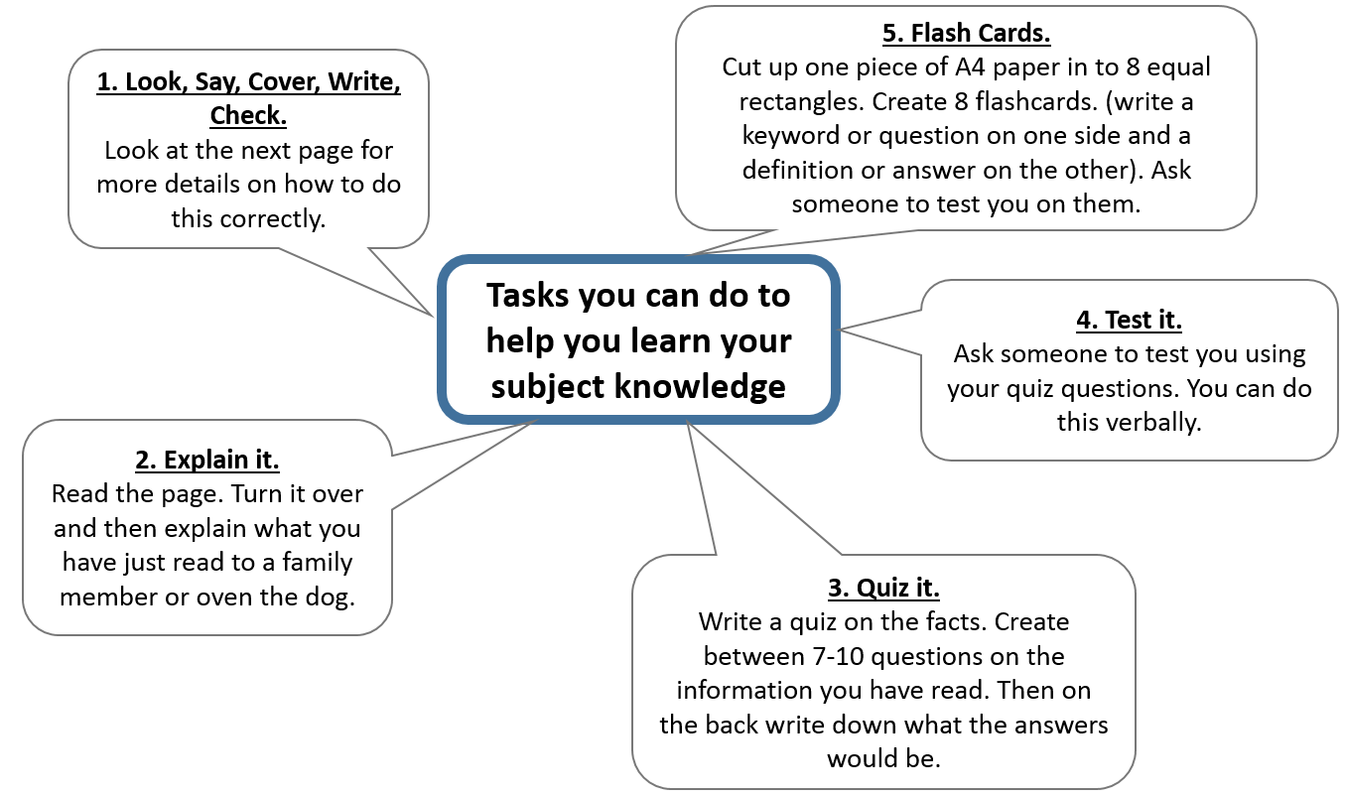

How should I use my Knowledge Organiser to study?

You should complete your Independent homework timetable on page 3, so that you know when to study.

Year 7, 8 and 9 should be completing one hour of homework each evening.

Year 10 and 11 should be completing two hours of homework each evening.

All students study because they value opportunities to learn and improve.

All students understand that in order to make excellent progress towards bright futures, they need to take responsibility for their own success and study at home as well as at the Academy.

We want you to have the very best opportunities available to you when you leave the Academy. Achieving excellent exam results in Year 11 and Year 13 is one way to help you to do that.

To gain excellent exam results in Year 11 and Year 13, you need to work hard in school every single lesson, every day in Year 7, 8, 9, 10 and 11. If you are in the Academy every day for 5 years you will have 4,750 hours of study time.

We want to make it as easy as possible for you to complete your study away from the Academy. Completing one hour of study per evening at home adds up to an extra 950 hours over your five years with us – which is like having an extra year of learning.

When and what should I study?

Why study?

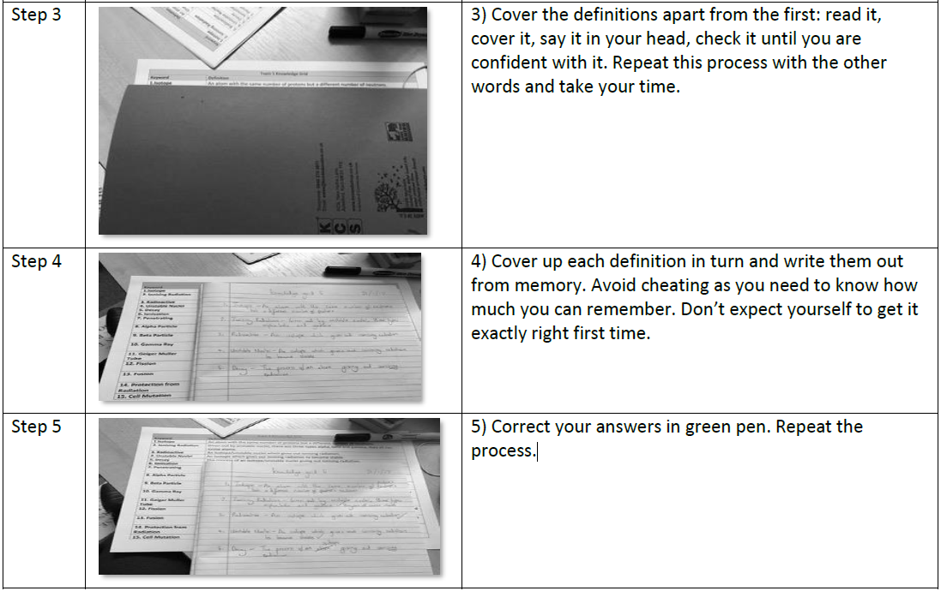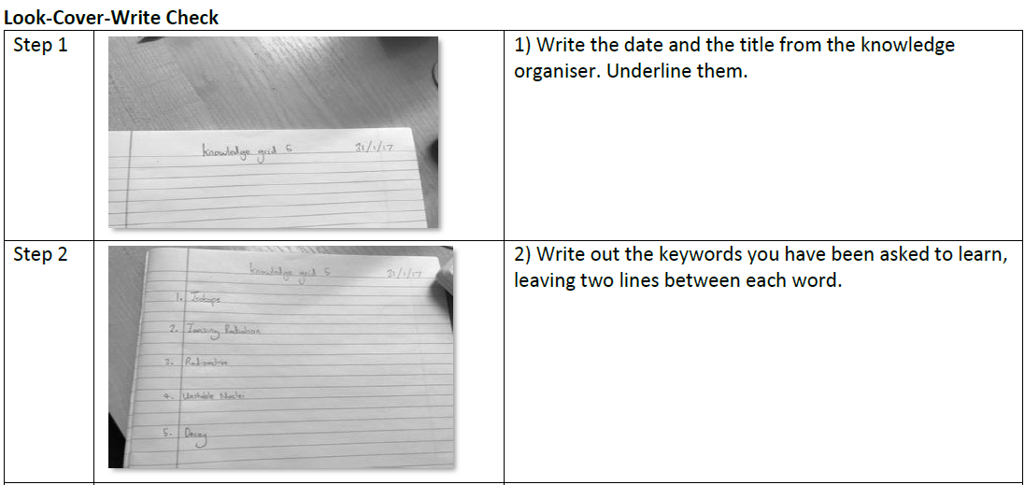

How should I use my Knowledge Organiser to study?

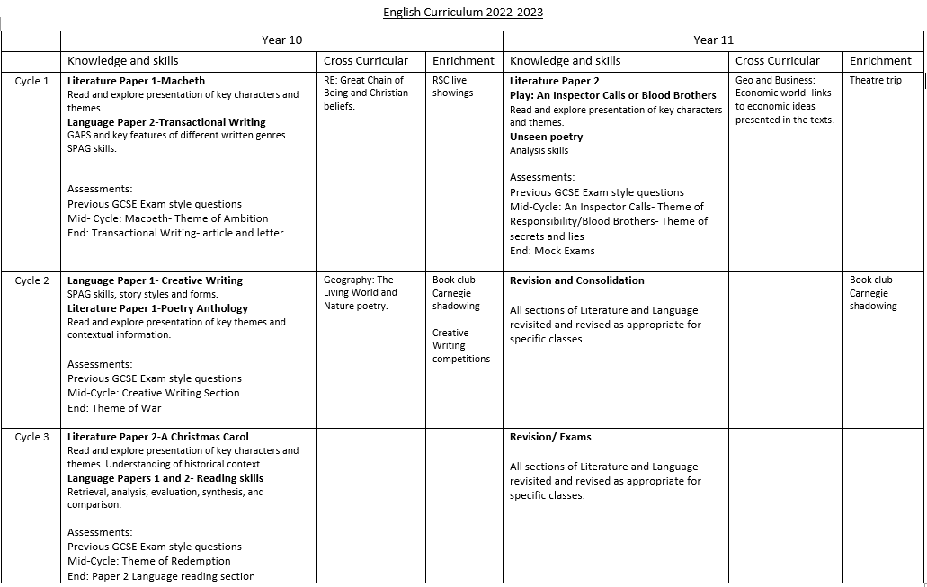

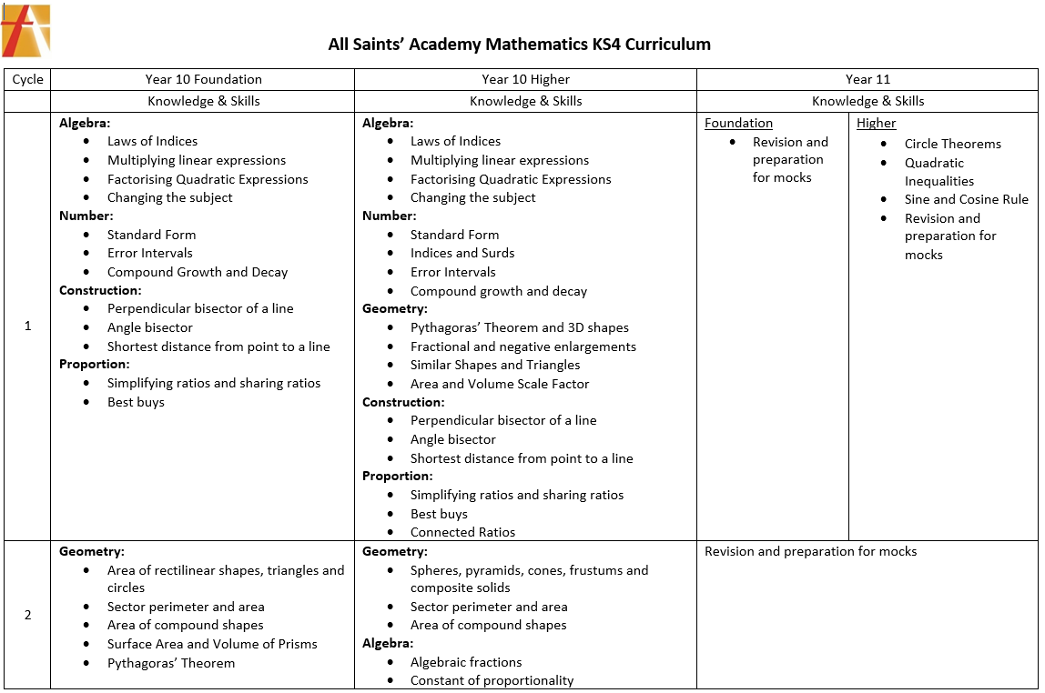

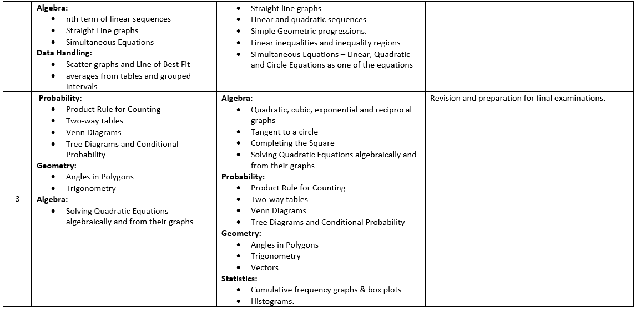

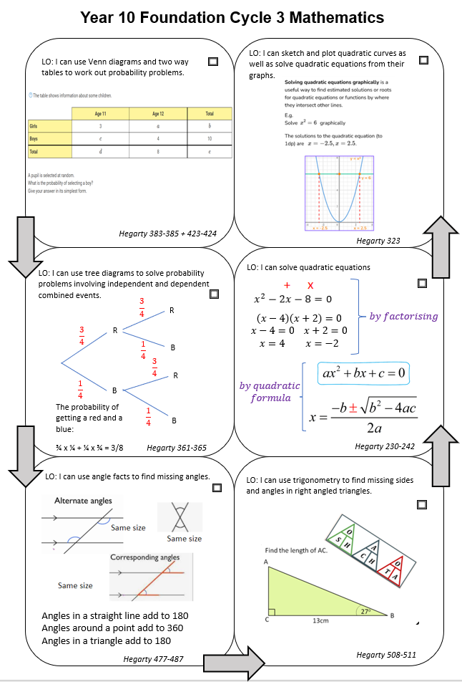

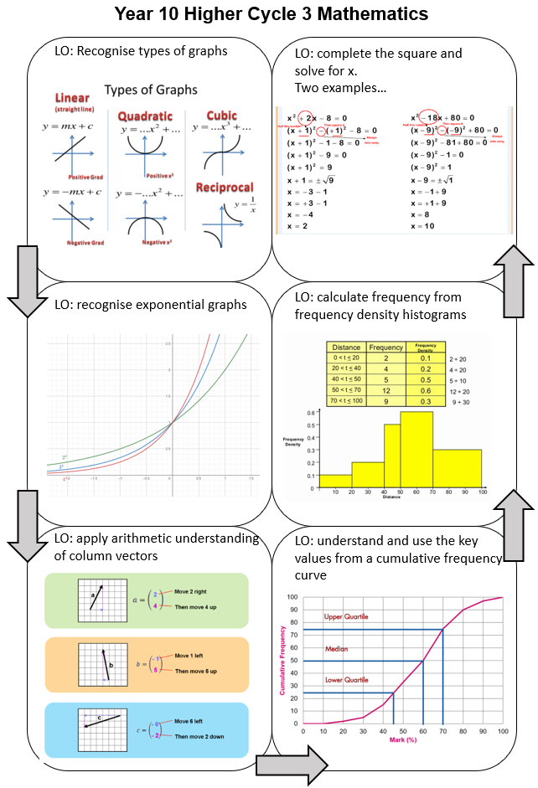

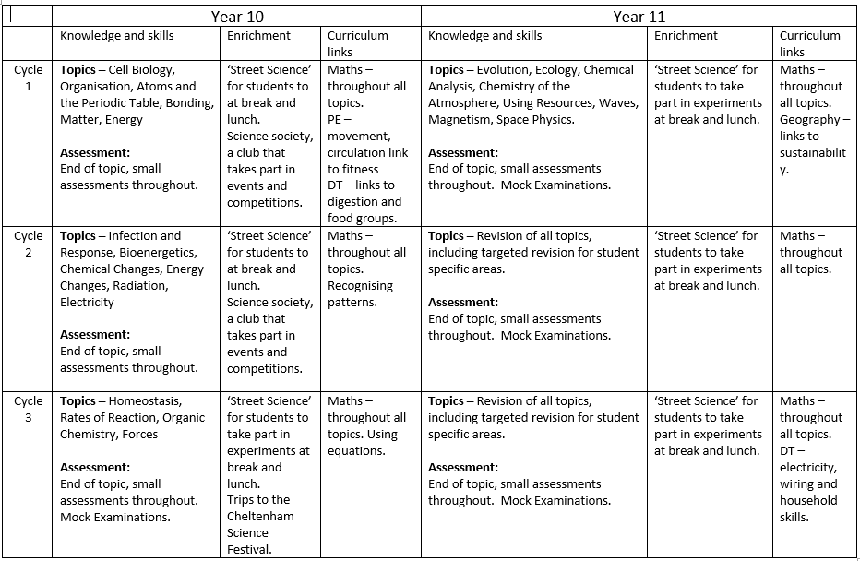

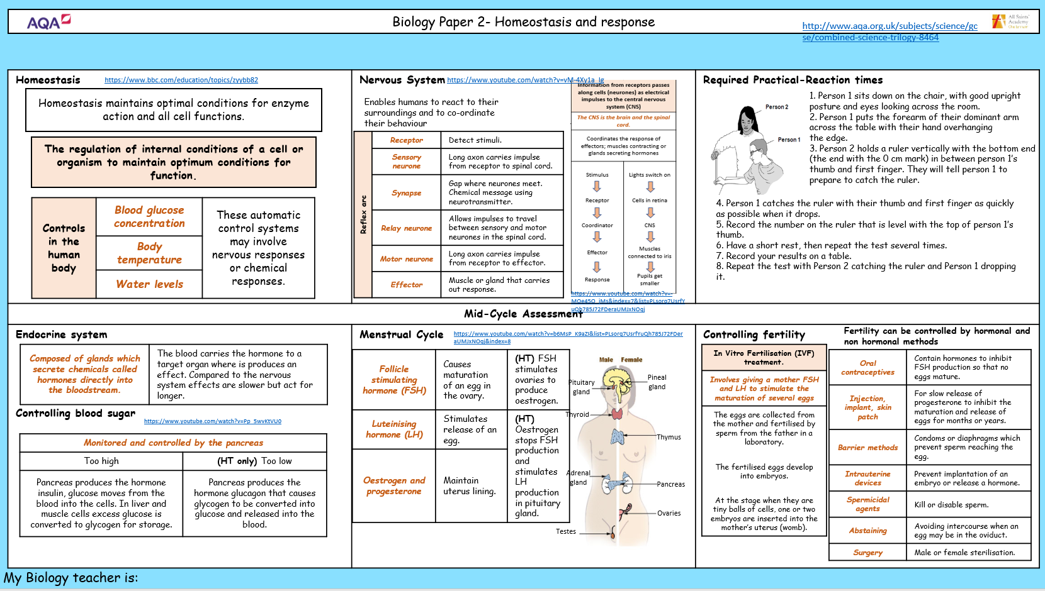

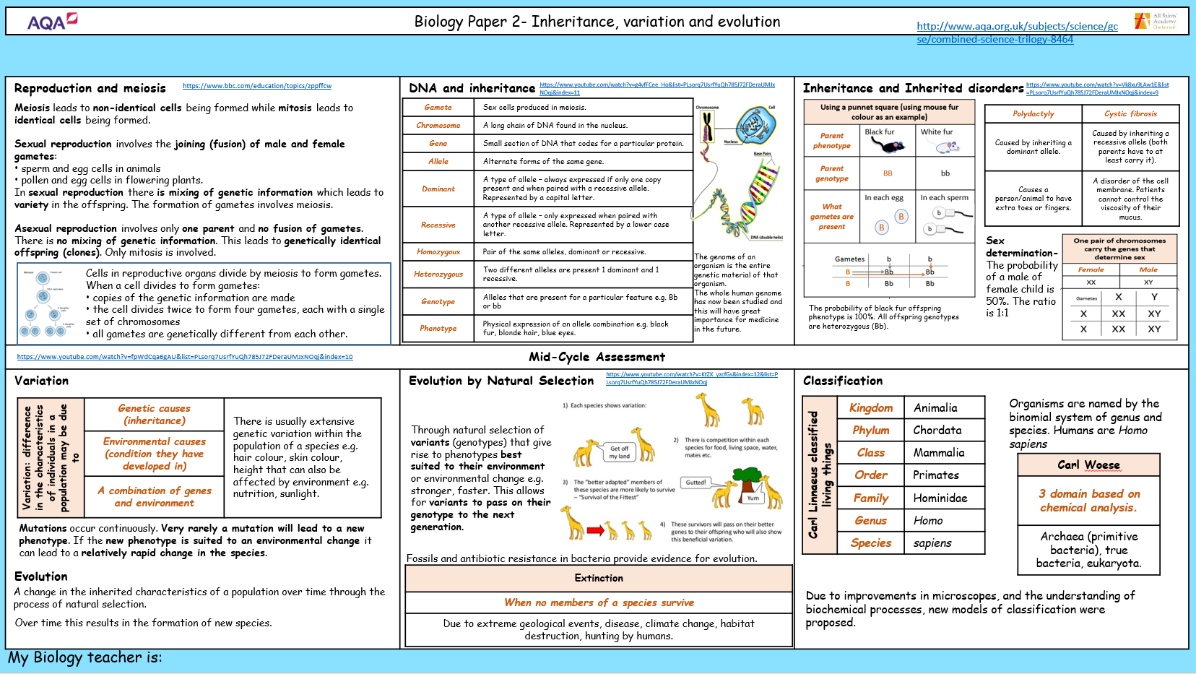

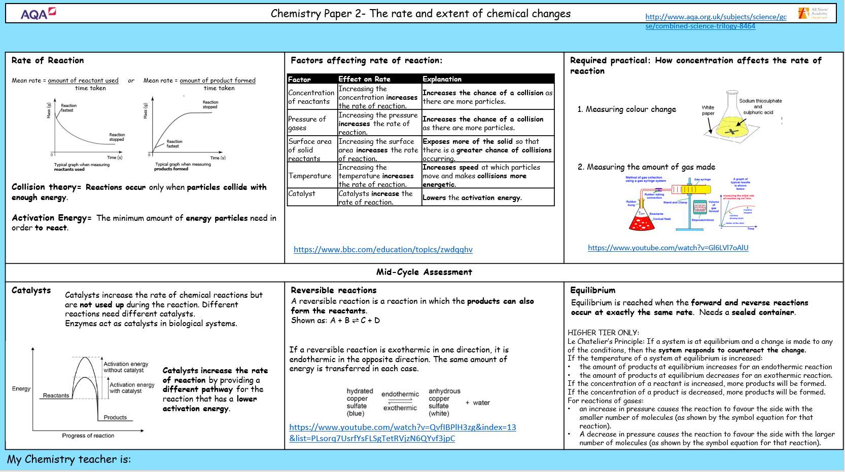

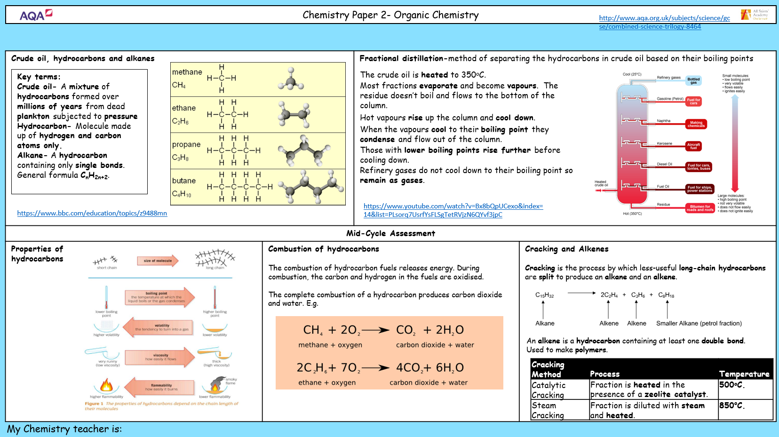

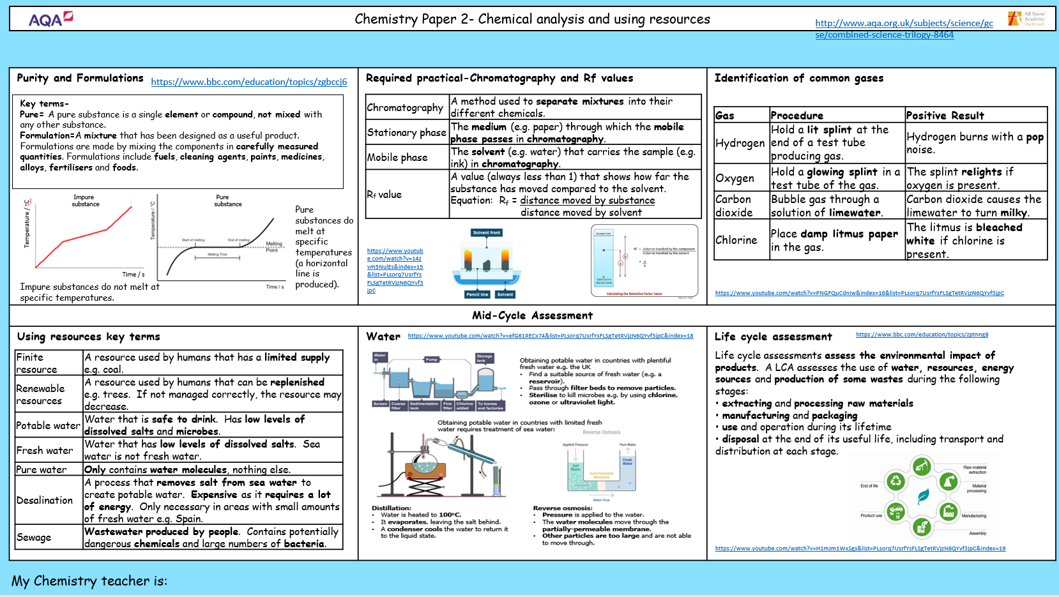

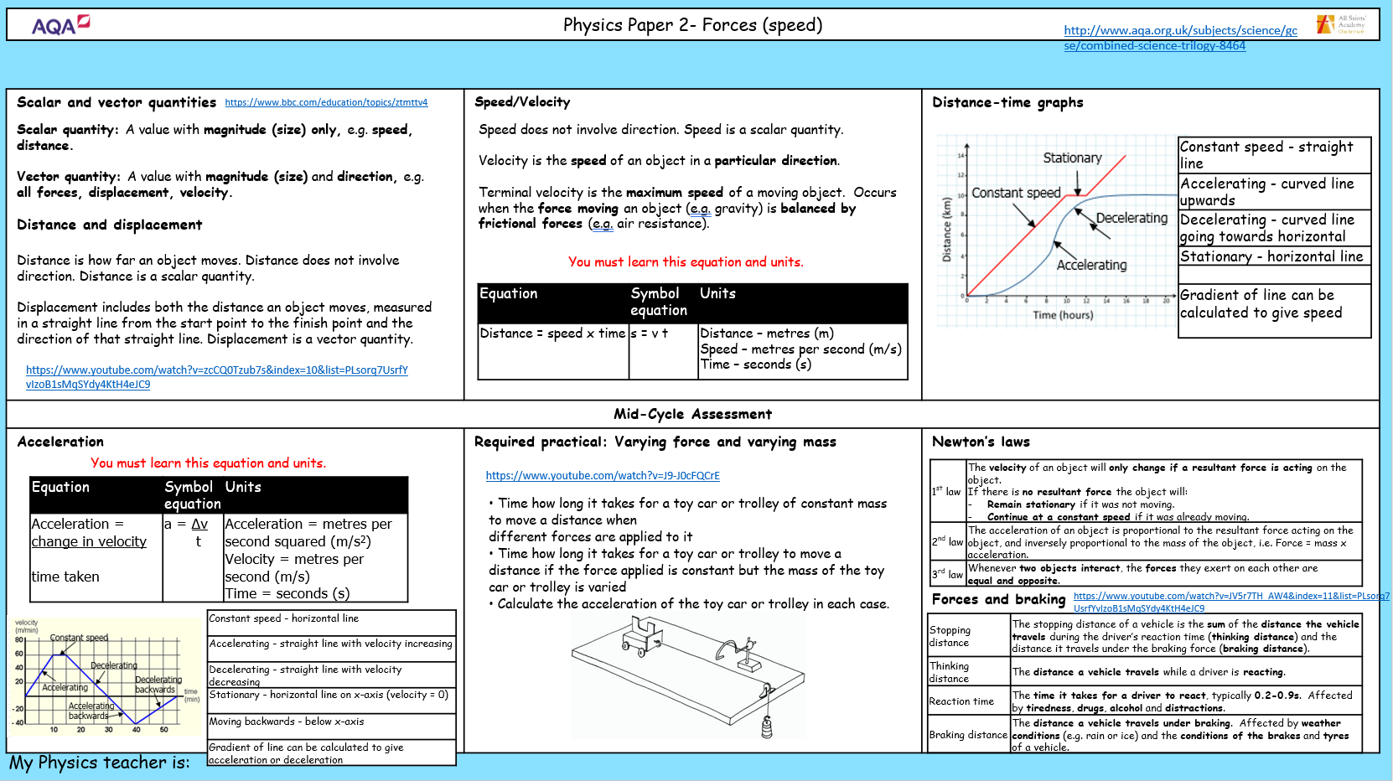

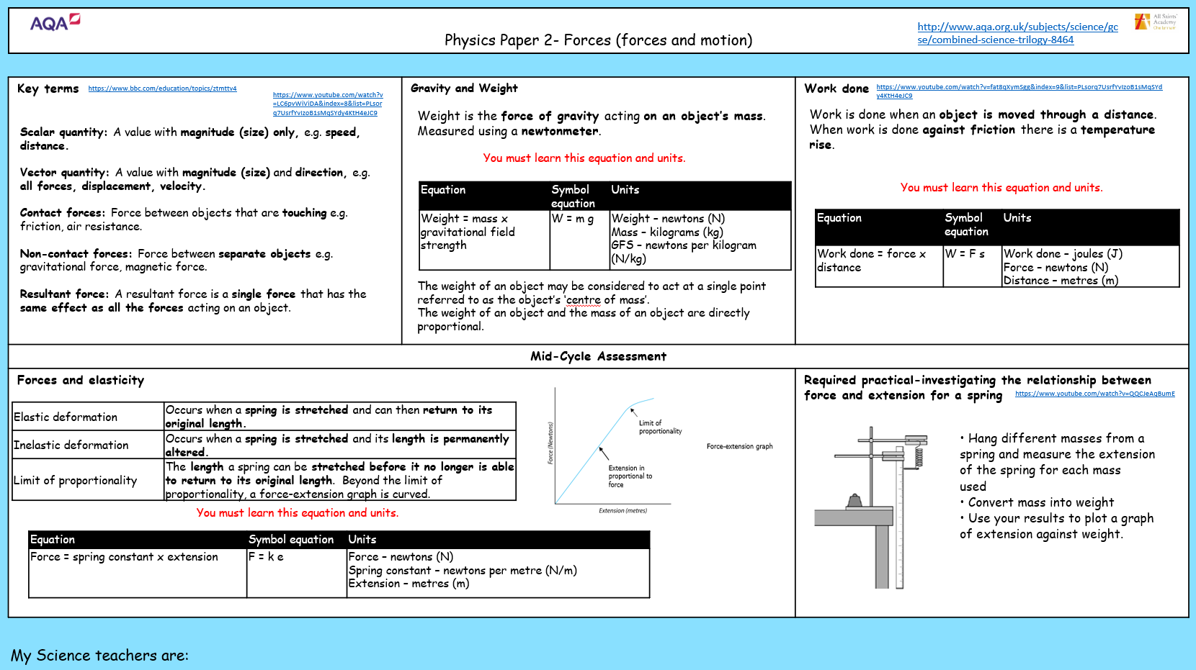

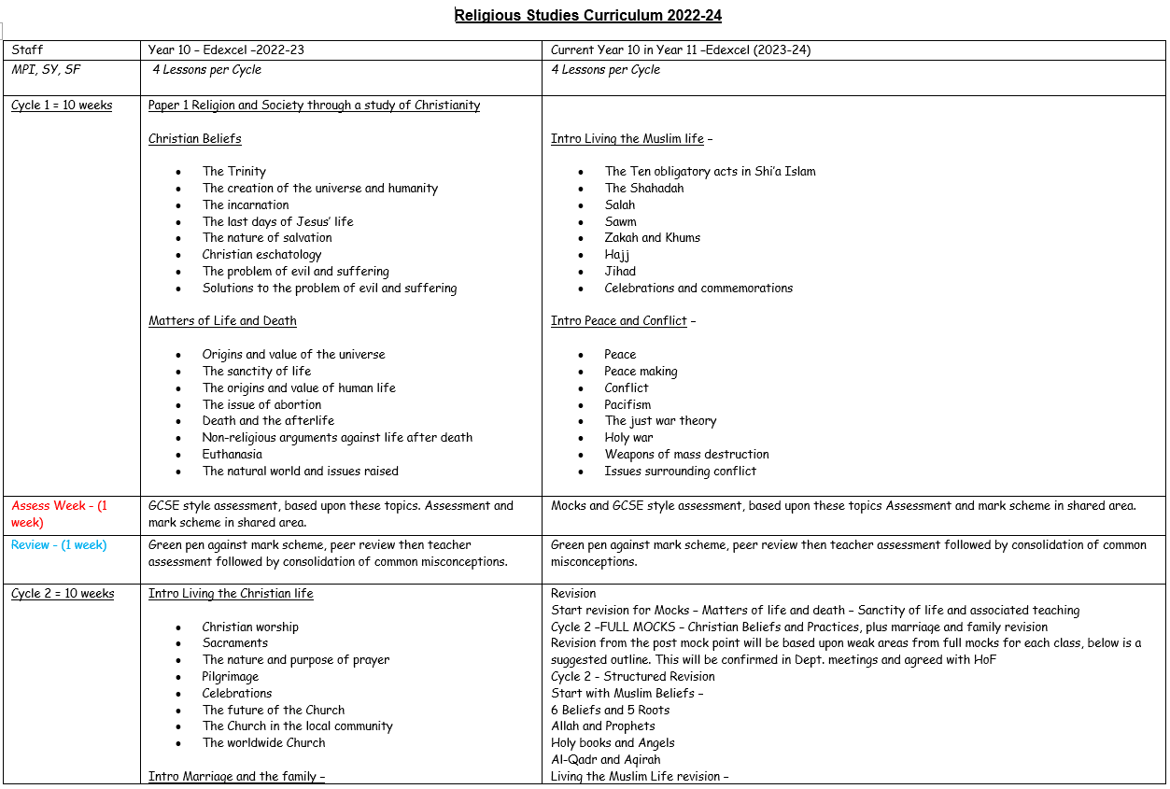

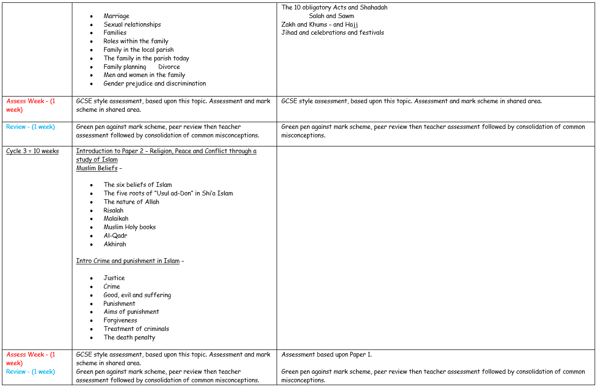

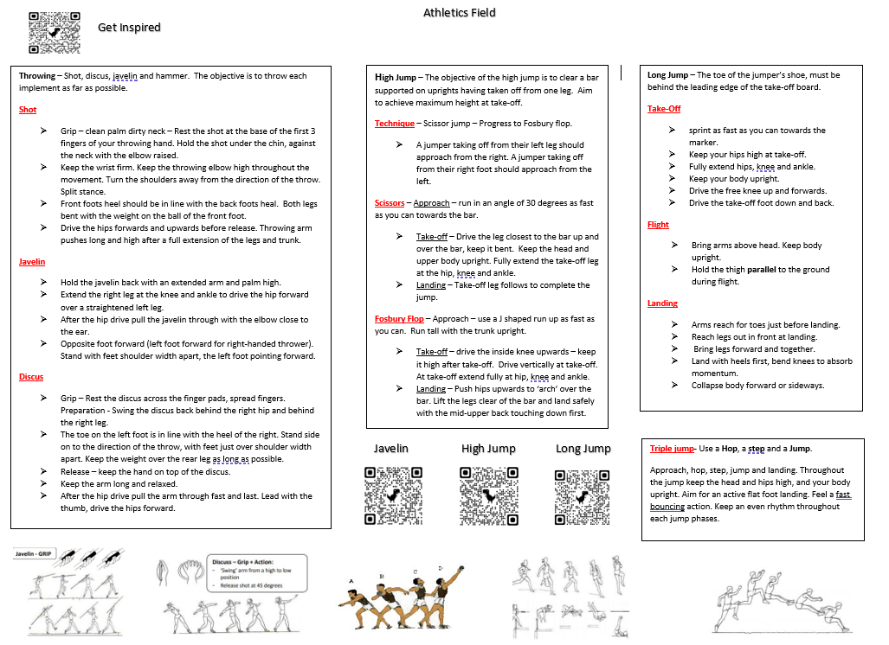

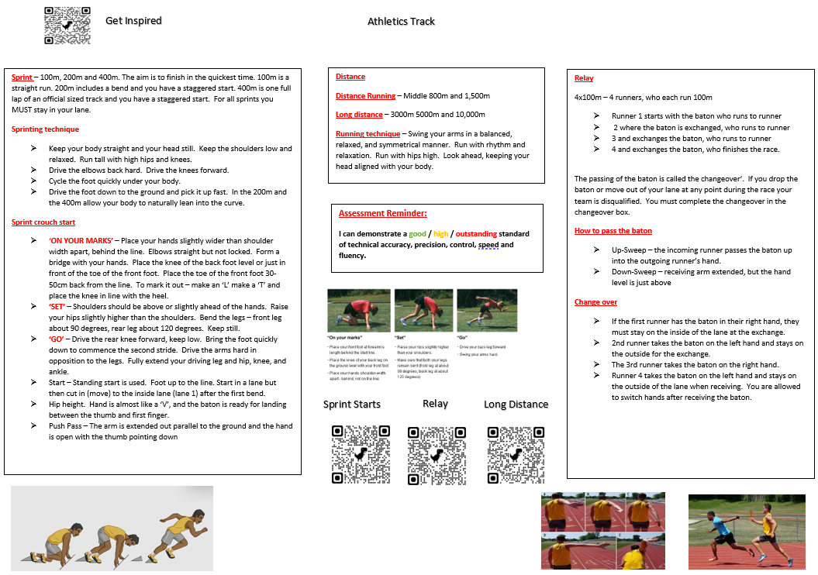

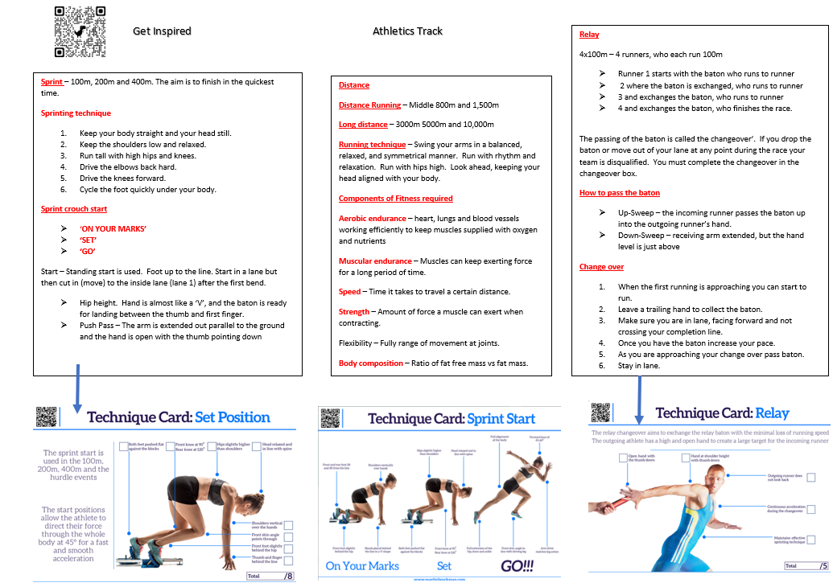

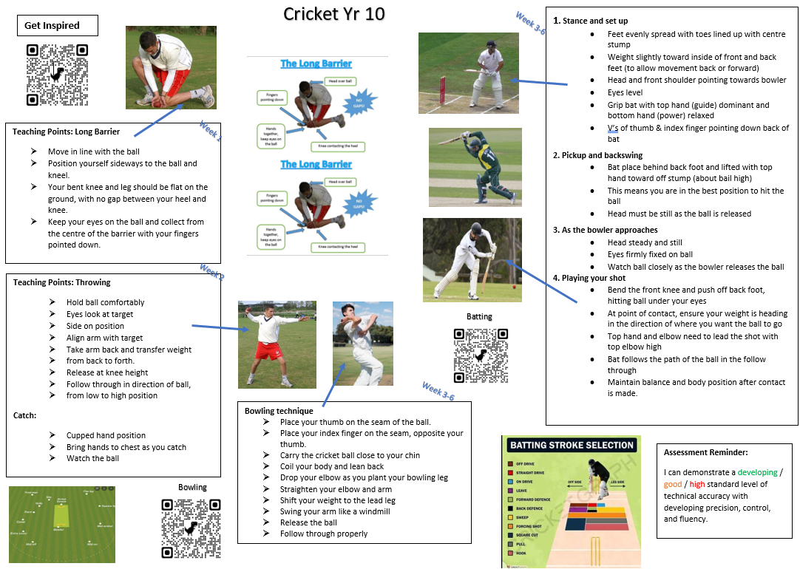

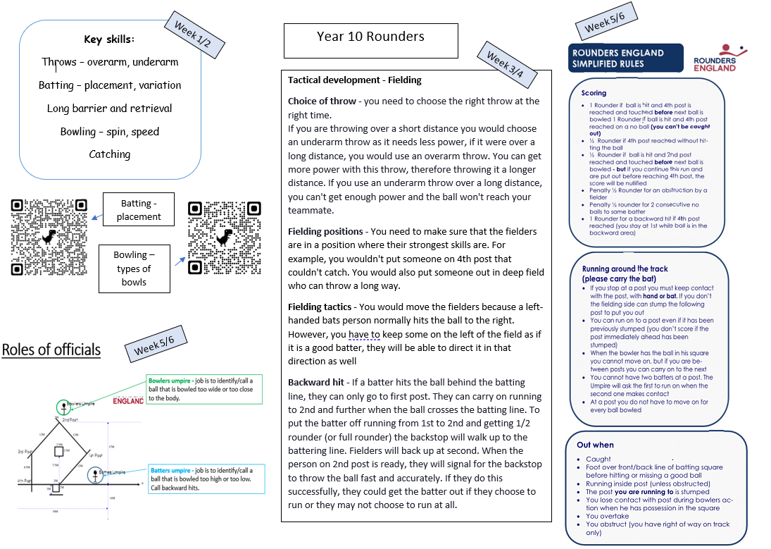

*Stick Option 1 subject Curriculum plan here*

*Stick Option 2 subject Knowledge Organiser here*

*Stick Option 1 subject Knowledge Organiser here*

*Stick Option 2 subject Curriculum plan here*

*Stick Option 2 subject Knowledge Organiser here*

*Stick Option 2 subject Knowledge Organiser here*

*Stick Option 3 subject Curriculum plan here*

*Stick Option 3 subject Knowledge Organiser here*

*Stick Option 3 subject Knowledge Organiser here*