Application Pack
School Staff Instructor (SSI)
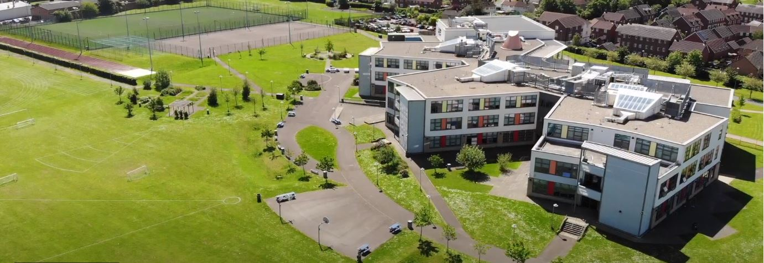
Where every member of our extended family realises their God-given potential, inspired by John 10:10. Jesus said ‘I have come so you may have life in all its fullness’.
2014 2018

www.asachelt.org

All Saints’ Academy, Cheltenham
Principal: Mr Dermot McNiffe

Post Title: Combined Cadet Force SSI
Start date: As soon as possible
Salary: Grade 7 (Points 21-25) £28,900 - £32,020 pro-rata (Actual pro-rata salary £10,664 to £11,815 per annum)
Hours of work: 16 Hours per week, term time only plus one week for inset days
Contract: Permanent
Closing date: 9am Monday 13th February 2023

We are looking to appoint a Combined Cadet Force (CCF) School Staff Instructor (SSI). The SSI will play a key role in the leading, developing and expansion of our RAF Cadet Force into an outstanding cadet unit. This role reports into the Director of Performing Arts Faculty.

As a central role in overseeing the efficient running of the contingent, the School Staff Instructor will plan, support planning, and assist with training/instruction to the RAF Cadet Unit staff and cadets.

The required working hours are 8.30 am to 5pm on a Monday and a Tuesday during term time and on staff inset days.

All Saints’ Academy is one of the best GCSE performing non-selective secondary schools in the Cheltenham and Tewkesbury area, and it has been for several years now.

Following another Good judgement, Ofsted reported:

• All Saints’ Academy is an inclusive school.
• Leaders and directors have been successful in improving pupils’ life chances by ensuring that they have achieved well in recent years.
• Staff hold fast to the school’s values and ethos, which unite them in their drive to improve standards.
• There is a clear determination to support pupils and their families to overcome barriers.

Ofsted 2018

Sponsored by the Anglican Diocese of Gloucester, we are an Academy serving at the heart of our local community. All Saints’ Academy has a Life Vision, ‘Where every member of our extended family realises their God-given potential, inspired by John 10:10. Jesus said 'I have come so you may have life in all its fullness'. We are an inclusive Church Academy who welcomes applications from all denominations and those of none.

What we offer:
- The Academy is in an attractive new building, within easy access to Cheltenham, Tewkesbury and the M5 with onsite catering facilities
- Entry into the Local Government Pension scheme
- Free access to the onsite gym facility
- Access to our Employee Assistance Scheme
- Free onsite parking including electric car charge points

The Academy is committed to safeguarding and promoting the welfare of children and young people and expects all staff and volunteers to share this commitment. Shortlisted candidates will be subject to an online search in line with Keeping Children Safe in Education 2022 recommendations. Successful applicants will be subject to enhanced DBS clearance.

To apply for this role please complete an online application form that can be found on the Academy website www.asachelt.org If you have any questions regarding this role please contact Katie Jordan, HR Manager at hr@asachelt.org

All Saints’ Academy is committed to ensure that all applicants and employees are given equal opportunities and that no applicants or employees are discriminated against on the basis of gender, gender reassignment, race, disability, pregnancy or maternity, sexual orientation, marital or civil partnership status, age or religion and belief.

Job Description

Post Title: CCF School Staff Instructor

Salary: Grade 7 Points 21-25

Hours: 16 Hours per week (working on A Monday and Tuesday)

Reporting to: Director of Performing Arts Faculty and Principal

Purpose of Role: The School Staff Instructor will play a key role in the leading, developing and expansion of our RAF Cadet Force into an outstanding cadet unit.
As a central role in overseeing the efficient running of the contingent, the School Staff Instructor will plan, support planning, and assist with training / instruction to the RAF Cadet Unit staff and cadets.
Qualifications SAAI (Cadet Skill at Arms Instructor) and Range Conducting Officer
& Experience (Min SA(SR)07)

Management/leadership experience.

Good practical knowledge of field tactics, map reading, skill at arms, first aid, drill, self-reliance/adventure training matters.

The ability to satisfy all criteria and checks relating to suitability to work in a school environment and the Ministry of Defence.

The ability to be patient, considerate and committed to the safeguarding of young people​​​​​​​.

Main Duties

Administration
- To support the Contingent Commander in running the RAF Cadet Unit.
- To provide administration for the RAF Cadet Unit.
- To organise and deliver military training to the RAF Cadet Unit.
- Support motivation of staff and cadets to develop their own military and adventurous training skills.
- Organise appropriate training and keeping records on individuals.
- To use the national cadet database (Westminster and Bader) to coordinate and plan consistent progress across all aspects of the training process.
- Maintaining environments and equipment in accordance with Joint Services Publication AC72133 and JSP 814.
- Carrying out general administration and maintenance duties, ensuring the efficient day to day running of the RAF Cadet Unit.
- Take an active role in raising aspirations of young people through mentoring sessions with pupils at the Academy.

Equipment
- Responsibility for the issue, care, maintenance, and accountability of all Ministry of Defence and RAF Cadet Unit equipment.
- Action all correspondence, emails and telephone calls and act as the main point of contact in the absence of the Contingent Commander.
- In liaison with the Contingent Commander, process claims for volunteer allowance for Cadet Force Adult Volunteers.
- Process applications for Cadet Force Adult Volunteers and Cadets to attend military and Cadet Adventurous Training Courses.
- Act as liaison with sponsor unit and the Cadet Training Team.
- Actively promote and support the RAF Cadet Unit in school and the wider community.

Security
- Maintain weapon and ammunition accounting, physical security issues and serviceability.
- Be responsible for conduct of Equipment Care and Mandatory Equipment Inspections as required.
- Maintain records and supervise the issue and return of weapons and ammunition
- Act as Unit Security Officer.
- Brief Headteacher and Cadet Force Adult Volunteers on current threats and Ministry of Defence policy regarding security.
- Conduct the annual Establishment Security Self-Assessment with the Contingent Commander.

Training
- Support Cadet Force Adult Volunteers for their Officer’s Initial courses at Service Headquarters.
- Prepare Cadet Force Adult Volunteers for courses.
- Prepare cadets for training courses where appropriate.
- Provide opportunities for cadets to take part in RAF Cadet Unit and shooting competitions.
- Assist with the production and implementation of training programmes for the RAF Cadet Unit.
- Attend and take a leading role in RAF Adventurous Training Camps.
- Process military paperwork and liaise with service Headquarters, attend miscellaneous RAF Cadet Unit training events as and when required.
- With the Contingent Commander, prepare the Contingent for its Annual Review and Biennial Inspection events and other public parades such as Remembrance Day.

Annual / Biannual Inspections
- Assist the Contingent Commander in development and delivery of Annual Review and Biennial Inspection Parades.
- Assist Cadet Force Adult Volunteers in preparing for annual administrative inspections by Service Headquarters.
- Maintain records and logs as appropriate for all types of inspections.

Additional Duties
- To play a full part in the life of the school community and to support its distinctive mission and ethos.
- To encourage pupils to follow this example.
- To actively support school policies.
- Any other duties as directed by the Principal.

This job description may be amended at any time, following consultation between the Principal and postholder. These are broad descriptions of the types of duties and/or activities expected of the post and are not an exhaustive list.

The Principal retains the right, as a condition of your employment, to require you to undertake such other duties as may reasonably be expected of you in this post. These duties will correspond to the general character of the post and are commensurate with its level of responsibility.

Person Specification
Qualifications and Training | Essential | Desirable
Security Awareness Training
Information Technology Security Awareness Training
SAAI (Cadet Skill at Arms Instructor) | *
Range Conducting Officer (Min SA(SR)07) | *
Clay Pigeon Shooting Association, Range Safety Officer
Good Knowledge of map reading, skill at arms, first aid, drill, self-reliance / adventure training matters
Infantry Level Tactical Knowledge to PSBC standard (including exercise planning - ECO)
Map Reading Instructor Qualification
First Aid Instructor Qualification
Drill Instructor Qualification
Mountain Leader Training (MLT) Qualification
Other Adventure Training Qualification
All Arms Storeman Qualification
Microsoft Office (competent in Word, Excel, and PowerPoint
HAZMAT & FMT 600 Driving Qualifications
MIDAS Minibus Driver | *
Full UK Drivers Licence

Note: All “” marked with a “*” above indicate, that it is a requirement to obtain these qualifications to pass the probationary period (within six months of start date).
Experience | Essential | Desirable
Held a SNCO or Commissioned Rank in the Regular, Reserve or Cadet Forces
Experience in working with cadets and young people
Instructional experience
Management / leadership experience
Experience working at training establishments, i.e. officer cadets, junior soldiers / recruit
Adventurous Training Expedition Planning
Familiarity with current training pamphlets
Air Rifle Maintenance
Management of Equipment Care Inspections and Logistics Care Inspections (ECIs and LCIs)

Personal | Essential | Desirable
Can satisfy all criteria and checks relating to suitability to work in a school
Good self-discipline, patient and committed
Good timekeeper
Ability to establish good working relationships with the armed services and motivate young people
Ability to evaluate and improve performance
Ability to delegate and coach CCF staff as well as cadets
Able to work under pressure and independently if necessary

