ASA Remote Access – November 2022
Overview
We have updated the remote access in-line with current security. This includes enabling 2 factor or multi factor authentication during the login process.
We have implemented this using a simple QR code to setup the use of a 6-digit, One Time Password (or OTP for short).
The best method for setting this up, is to use either of the following Smart phone Apps:
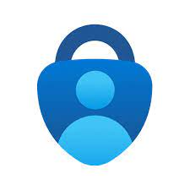
Microsoft Authenticator App | Google Authenticator App

If you don’t have a smartphone, don’t worry we have enabled a Google Chrome, or Microsoft Edge extension called authenticator, which we can use, more on this in the steps below.
Accessing Remote Access
You can access the remote access system at the website: https://remote.asachelt.org
You will arrive at the following website (please note you do NOT need to enter your full email address, just your username).
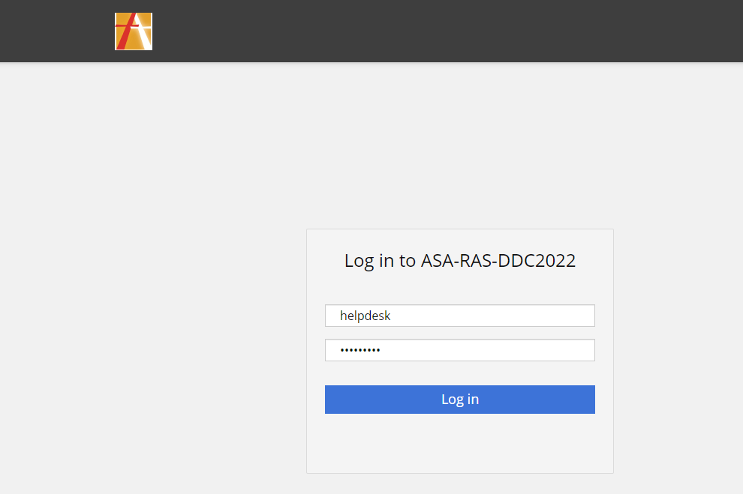
After logging in, for the first time, you will be prompted to setup your OTP using a QR code.
The easiest way is to scan the on-screen QR code using either of Microsoft Authenticator or Google Authenticator Apps, then enter in the 6-digit code that appears in your Authenticator App of choice.
Working without a Smart Phone/Authenticator App
The alternative is to use the extension, which we will demonstrate how to get setup below.
The easiest method of enabling use of the extension, is to sign into the Google Chrome browser using your school email address and sync your account settings.
To do this, please follow the steps below:
- Open Google Chrome, and click the user profile icon in the top right-hand corner:
- Click the “Turn on Sync” Button in blue, as shown below, then enter your school email address. After the second step, you will then be redirected to an Office 365 Sign in Process, so fill your email address and password in again. Make sure to accept the following two Google Prompts to allow asachelt.org to manage the profile and allow sync.

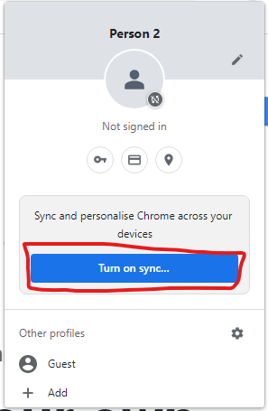 | 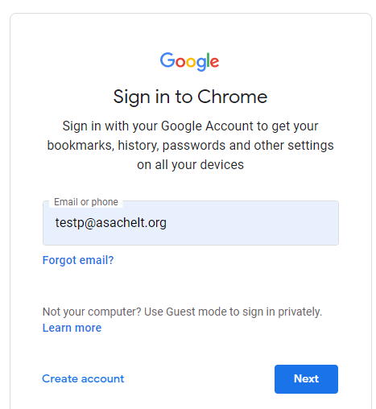
Step 1 | Step 2
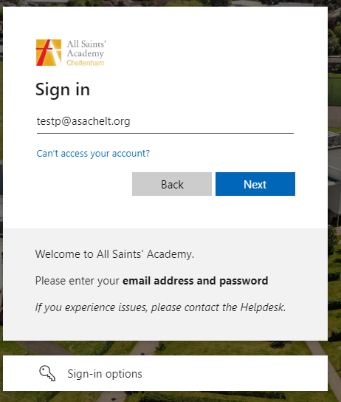 | 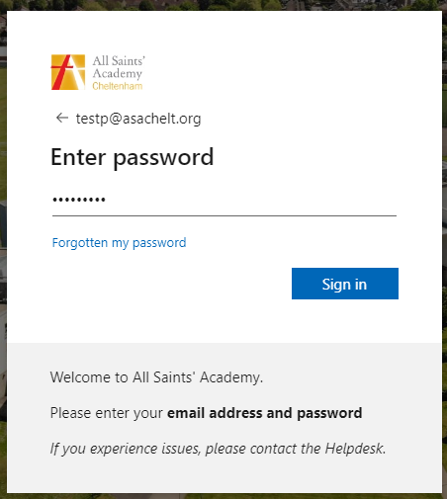
Step 3 | Step 4
Working without a Smart Phone/Authenticator App (continued)
- Once logged into Chrome Browser, please click on the ASA Remote Access Link under the ASA Managed Bookmarks folder, you will also see the Authenticator Extension as highlighted in yellow:
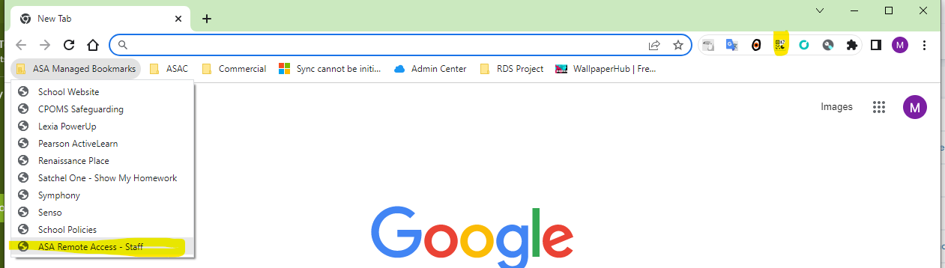

- At the Remote Access Login Screen, login using your normal username and password. Please note: You do not need to enter your full email address here.
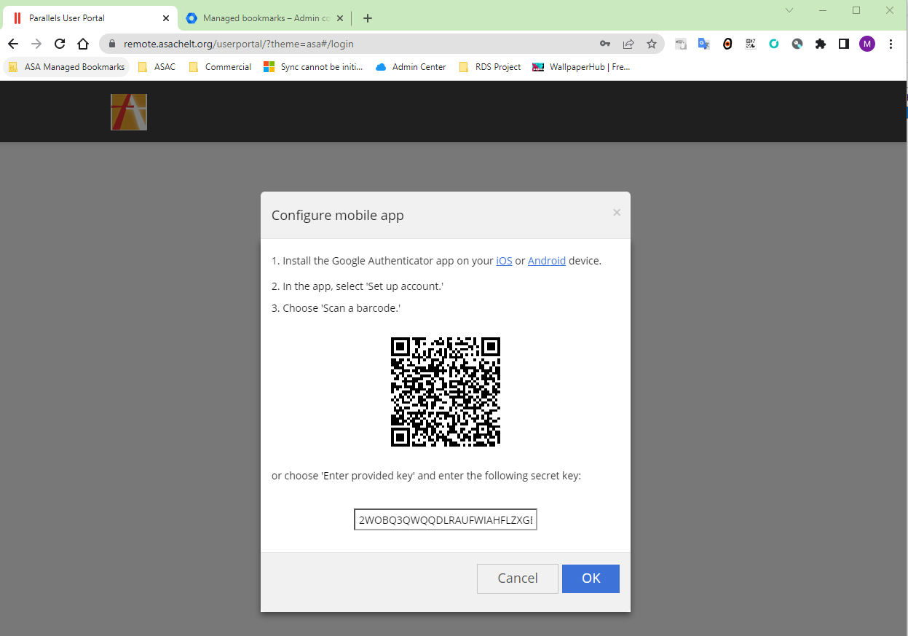

At the next prompt, you can either:

  - Use the Authenticator App of choice
  - Use the Authenticator Extension
To setup the extension, click the extension, then the scan QR code as below:
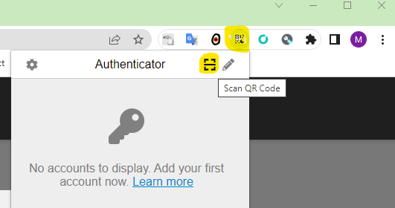

Click and drag around the QR code on screen, then release. You have now added this functionality. Click the Authenticator Extension again, to get your 6 digit one time code.
