Application Pack
Learning Supervisor
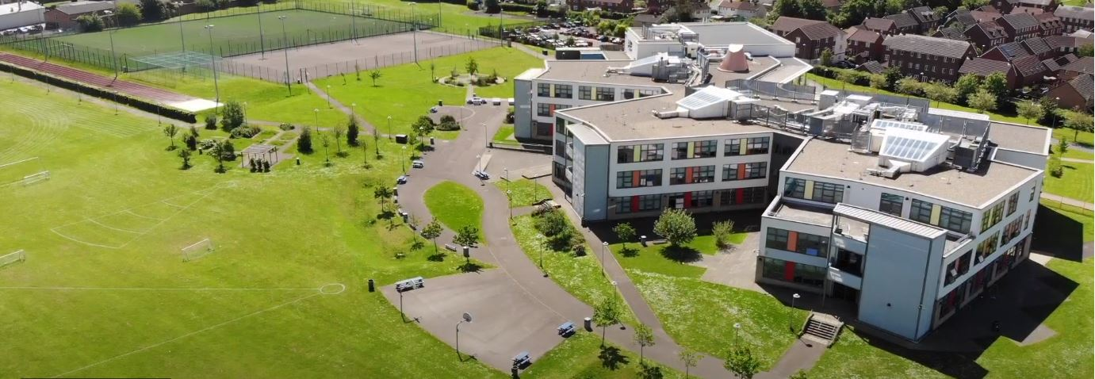
Where every member of our extended family realises their God-given potential, inspired by John 10:10. Jesus said ‘I have come so you may have life in all its fullness’.
2014 2018

www.asachelt.org

All Saints’ Academy, Cheltenham, Gloucestershire.
Principal: Mr Dermot McNiffe

Learning Supervisor
Start date: As soon as possible
Salary: Grade G (Points 8-20) £20,852 - £26,446 pro-rata. (Pro-rata salary range £15,639 - £19,834 per annum)
Hours of work: 32.5 hours per week/ Term time plus one week for inset days
Contract: Permanent
Closing date: 9am Monday 16th May 2022

We are seeking to appoint a Learning Supervisor to supervise students in the absence of a teacher, ensuring that students continue to make progress. All work will be set by the teacher. The Learning Supervisor may also support learning in subject areas when there is no need for lessons to be covered. This is an excellent opportunity for someone considering or returning to the teaching profession.

All Saints’ Academy is one of the best GCSE performing non-selective secondary schools in the Cheltenham and Tewkesbury area, and it has been for a number of years now.

Following another Good judgement, Ofsted reported:

• All Saints’ Academy is an inclusive school.
• Leaders and directors have been successful in improving pupils’ life chances by ensuring that they have achieved well in recent years.
• Staff hold fast to the school’s values and ethos, which unite them in their drive to improve standards.
• There is a clear determination to support pupils and their families to overcome barriers.
Ofsted 2018

Sponsored by the Anglican Diocese of Gloucester, we are an Academy serving at the heart of our local community. All Saints’ Academy has a Life Vision, ‘Where every member of our extended family realises their God-given potential, inspired by John 10:10. Jesus said 'I have come so you may have life in all its fullness'.

We are an inclusive Church Academy who welcomes applications from all denominations and those of none.

What we offer:
- The Academy is in an attractive new building, within easy access to Cheltenham, Tewkesbury and the M5 with onsite catering facilities
- Entry into the Local Government Pension scheme
- Free access to the onsite gym facility
- Access to our Employee Assistance Scheme
- Free onsite parking including electric car charge points

The Academy is committed to safeguarding and promoting the welfare of children and young people, and expects all staff and volunteers to share this commitment. Successful applicants will be subject to enhanced DBS clearance.

To apply for this role please send a covering letter and a completed Support Staff Application Form to Katie Jordan, HR Manager at hr@asachelt.org

All Saints’ Academy is committed to ensure that all applicants and employees are given equal opportunities and that no applicants or employees are discriminated against on the basis of gender, gender reassignment, race, disability, pregnancy or maternity, sexual orientation, marital or civil partnership status, age or religion and belief.

Job Description

Post Title: Learning Supervisor

Hours: 32.5 hours per week
Term Time Only plus Inset Days

Reporting To: Vice Principal (Curriculum)

Key Activities
- To undertake whole class supervision in the absence of a teacher, setting work previously prepared.

- To develop curricular knowledge as required by the Academy.

- To apply the Academy’s behaviour and standards policies and report any difficulties via the established procedure.

- To assess elements of class work and homework under the guidance of the class teacher or Department Leader.

- To undertake observations of the students and contribute to student records.

- To supervise the work of Teaching Assistants linked to any supervised groups of learners.

- To attend Academy/department meetings to contribute to the discussions about individual students as required.

- To attend Parents’ Evenings, as required, to contribute to the discussions about individual student’s progress.

- Invigilate internal and external examinations when required.

- Register and record student attendance.

- Provide students with the necessary resources for their learning.

- Inform class teachers / Department Leaders / Achievement Leaders as appropriate about the behavior of students during the class and any issues arising.

- To manage resources effectively and ensure learning are left tidy and ready for the next lesson.

- To collect any completed work after the lesson and return it to the appropriate teacher.

- To provide consistent and effective support in line with the requirements and responsibilities of your role.
Accountability
- To be responsible for collecting and organising a range of resources to deliver a range of high quality learning opportunities.

- For the inclusion and acceptance of all pupils within the classroom.

- To be aware of particular pupils’ specific needs as identified in IEP’s.

- Be aware of and comply with policies and procedures relating to child protection, health and safety, security, confidentiality and data protection. Reporting all concerns to the appropriate person.

Other Specific Duties

All support staff will be expected to accept reasonable flexibility in working arrangements and the allocation of duties, in pursuance of raising student achievement and effective team working. Support Staff will also:

- model the ethos and vision for the Academy
- to continue personal professional development as required
- to actively engage in the performance review process
- support whole Academy acts of worship and prayer for the day.

It is important that all staff recognise that they are an integral part of the Academy and have a duty to contribute to its overall effectiveness both within their specific areas and beyond.

It is the vision of the Academy to involve all support staff in the life of the Academy and in particular in supporting students as House Tutors, Mentors and other appropriate ways.

Whilst every effort has been made to explain the main duties and responsibilities of the post, each individual task may not be identified. Employees will be expected to comply with any reasonable request from the Principal to undertake work of a similar level that is not specified in this job description and to undertake all duties reasonably requested by their line manager in a manner consistent with the vision of All Saints’ Academy.

The academy will endeavour to make any necessary reasonable adjustments to the job and the working environment to enable access to employment opportunities for disabled job applicants or continued employment for any employee who develops a disabling condition.

PERSON SPECIFICATION

Learning Supervisor

 | Essential | Desirable
Qualifications | - Evidence of good literacy and numeracy. At least a GCSE grade C or Grade 5 in Maths and English (or equivalent qualification) | - Experience of working with groups of young people  - Education/ Teaching qualification or working towards
Skills | - Ability to work independently.  - Ability to inspire, lead and support young people.  - Show initiative and approach challenges with a positive attitude.  - Ability to respond to changes at short notice. | - Ability to use ICT as a learning and teaching tool and a motivator.
General | - Flexible and enthusiastic attitude.  - Clear ability to relate to young people.  - A commitment to a positive culture of learning.  - Resilience in supporting and developing young people.  - Excellent communication skills.  - Highly professional in punctuality and attendance. | - Ability to be part of a team.  - Experience of leading groups of young people in a learning environment

