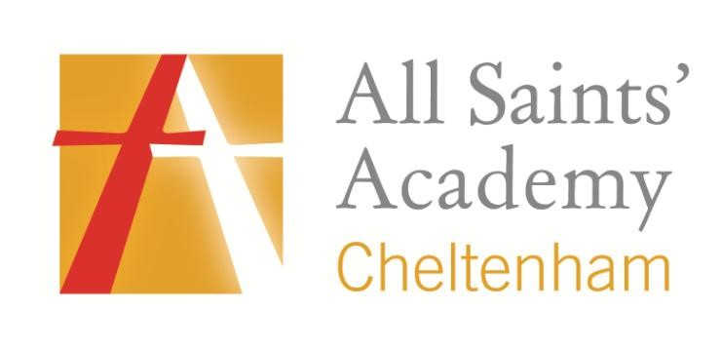

Policy Name: Uniform Policy and Sixth Form Dress Code

1. Sponsors’ Statement

The policies of All Saints’ Academy, with its distinctive Anglican and Catholic foundation, exist to support the Sponsor’s Christian vision, ethos and values that are embedded in the day-to-day and long term running of the Academy. Each policy evidences the commitment of the Sponsor to developing Body, Mind and Spirit.

2. Introduction

2.1 At All Saints’ Academy we want students to take pride in their appearance and hold a collective identity. We believe this will be an important strategy in raising aspirations and standards.

2.2 The Academy’s Uniform Policy applies equally to all pupils, irrespective of their gender, race, religion, belief, special educational needs or disability subject to health and safety and welfare considerations. The Academy will consider reasonable requests to alter the school uniform, for example, to accommodate mandatory and genuine religious requirements (subject to health and safety) and reasonable adjustments for disabled pupils or other special circumstances.

3. Uniform, Years 7 to 11 inclusive

OBLIGATORY

Plain black All Saints’ Academy blazer with Academy logo on the breast pocket.

A white collared uniform shirt with top button.

Black knee-length skirt (at least 22” long) or trousers with the All Saints’ Academy logo.

A black tie with the Academy logo.

Black socks or black tights.

Plain black slip on or lace up flat school shoes.

Optional

A black jumper with the Academy logo.
Jewellery

A Watch
One stud only to be worn in each ear lobe if desired.
Other body and facial piercings are not permitted (except for mandatory or genuine religious requirements).

HAIRSTYLE

No extremes of fashion will be allowed.
Students’ hair should be smart. Extreme haircuts are not permitted, such as ‘skinhead style’ or areas shaved to create patterns or less than Grade 2 length.
Only simple dark accessories should be worn.
Long hair must be tied back for PE and practical activities.
Brightly coloured dyes are not acceptable
SCHOOL BAG

All students must carry a sensible school bag appropriate for carrying school books and equipment, such as a rucksack, tote bag or other plain bag.
COSMETICS

Make up is not permitted.
Nail varnish, false nails, acrylics are not permitted.
PE KIT – OBLIGATORY

Black shorts/skort
Black and red reversible sports top with Academy logo
Black and red polo top with Academy logo
Back and red hooped socks
A pair of trainers that will support and cushion your child’s feet and joints through practical activities.
OUTDOOR CLOTHING

A waterproof coat is recommended, particularly in Winter, as this can be worn when outside at breaks.
Hoodies and sports tops may not be worn as coats.
Leather or leather-look or denim coats/jackets are not permitted.

Cyclists should wear a helmet, and reflective clothing is encouraged.

Students are expected to wear correct uniform to and from the Academy.
As a general rule: Any clothing or non-natural change to body or hair that might lead to disruption of learning is not allowed.
Students wearing incorrect uniform will be offered items to borrow when possible, or will work in Reflection or will be sent home until the matter has been addressed.
Parents are welcome to contact the Academy for clarification of any aspect of the uniform policy.

There are two stockists of our Academy uniform:

Schooltogs - 252 High Street, Cheltenham GL503HF Tel: 01242 523 632

Universal Uniform – Kingsditch Trade Park, V1, Kingsville Road, Cheltenham GL51 9LX Tel: 01242 580062
Sixth Form Dress Code
Sixth formers should be smartly dressed at all times and take pride in their appearance, recognising that they are dressing for a formal working environment and helping to set the tone for the rest of the Academy.

Smart business wear is expected at all times.
Jewellery should be kept to a minimum, consistent with health and safety. Apart from pierced ears, no other body piercing is allowed and no visible tattoos.
Practical subjects will make special arrangements for their lessons when necessary. Students will need to change for practical sessions.
Sixth Form students should adhere to the dress code and may be sent home to change if deemed unsuitable.

Dress Code - OBLIGATORY

Blazer or V-neck jumper/cardigan

Tailored business skirt, dress
(worn on or just above the knee)

Smart suit-style trousers
(no tight, skinny fit or elasticated skirts or trousers)
Tailored shirt or blouse tucked in. (No t-shirts, see-through fabric, emblems or baggy types)
Formal black, brown, grey or navy shoes or smart boots permitted.

(No canvas, trainers or casual type, ‘Ugg’ or Wellington styles)
No urban/hiking style boots

We are conscious of the need to ensure that any form of dress within the school is cost effective and practical, and can be purchased in High Street shops. We have researched this and can provide information upon request.

