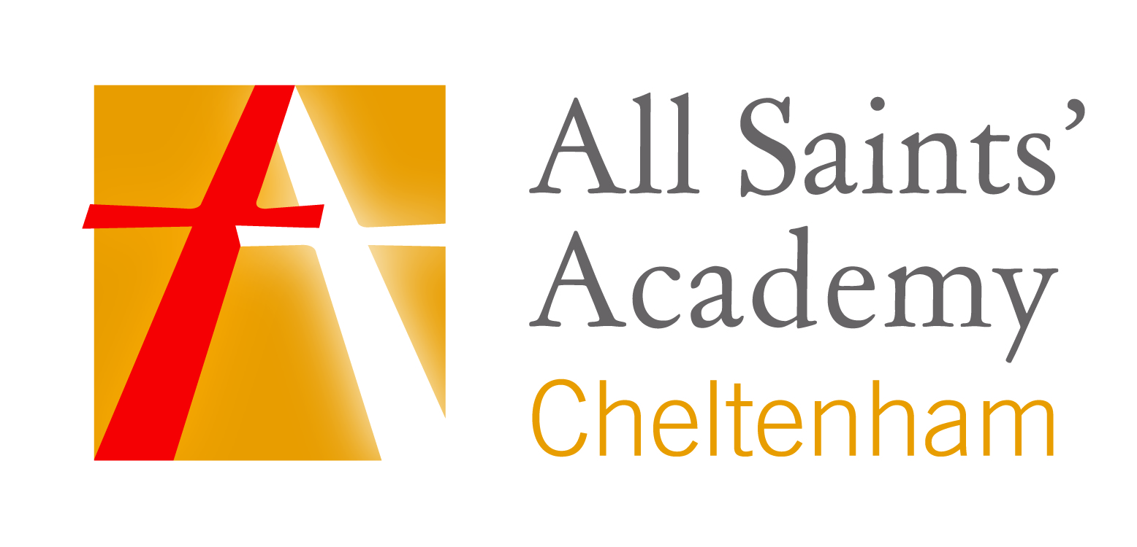

Policy Name: Uniform Policy and Sixth Form Dress Code

Reviewed: | July 2023
Next Review: | July 2025
Staff Owner: | Mr Liam Wilkinson
Trustee Owner: | Mr Henry Watson
Contents

1. | Sponsors’ Statement................................................................................................................... | 3
2. | Introduction ............................................................................................................................... | 3
3. | Uniform, Years 7 to 11 inclusive ................................................................................................. | 3
4. | Sixth Form Dress Code ............................................................................................................... | 5
1. Sponsors’ Statement

1.1 The Policies of All Saints’ Academy, with its distinctive Anglican and Catholic foundation, exist to support the Sponsors’ vision, Christian ethos and values that are embedded in the day-to-day and long term running of the Academy. Each policy evidences the commitment of the Sponsors to developing Body, Mind and Spirit.

2. Introduction

2.1 At All Saints’ Academy our uniform exemplifies our high expectations. It is an important part of being in our Academy and a member of our community because:
- Uniform creates a sense of professionalism and a clear sense of standards.
- Uniform creates a sense of pride, identity and belonging both in Academy and during the journey to and from school.
- Uniform removes the points of difference between students, helping to equalise social status and promote equality and inclusivity.
- Uniform creates a ‘working environment’ mindset and helps to separate home and Academy life.
- Uniform helps to promote wellbeing, improve self-confidence and reduce bullying.

2.2 The Academy’s Uniform Policy applies equally to all pupils, irrespective of their gender, race, religion, belief, special educational needs or disability subject to health and safety and welfare considerations. The Academy will consider reasonable requests to alter the school uniform, for example, to accommodate mandatory and genuine religious requirements (subject to health and safety) and reasonable adjustments for disabled pupils.

3. Uniform, Years 7 to 11 inclusive

UNIFORM
Black All Saints’ blazer with logo as supplied by Monkhouse.
Plain white uniform polyester/cotton shirt (not polo shirt)
Black uniform style trousers with the Academy logo as supplied by Monkhouse or plain black knee length skirt (or at least 22” long) with the Academy logo as supplied by Monkhouse.
All Saints’ black tie with the Academy logo as supplied by Monkouse
Black socks or black tights
Sensible, low heeled plain black leather type shoes (not trainers, boots or suede)
SCHOOL BAG
All students must carry a sensible school bag appropriate for carrying school books and equipment, up to A4 size.

Clothing worn to and from the Academy

An appropriate outdoor coat should be worn to the Academy in winter weather, e.g. waterproof coat.

‘Hoodies’ and sports tops may not be worn as coats. Leather, leather-look or denim coats/jackets are not permitted. Cyclists should wear a helmet, and reflective clothing is encouraged.

Students are expected to wear the correct uniform to and from the Academy.
PE KIT – Compulsory
Black shorts
Black & red reversible sports top with logo
Black & red – unisex or girl fit - polo top with logo
Black & red hooped socks
Optional Uniform Items
Black Academy jumper with logo as supplied by Monkhouse
Jewellery
A watch can be worn.
One stud only to be worn in each ear lobe.
Other body and facial piercings are not permitted (except for mandatory or
genuine religious requirements).
Hairstyle
No extremes of fashion will be allowed.
Students’ hair should be smart. Extreme haircuts are not permitted (boys, minimum grade 2 length).
Only simple dark accessories should be worn. Brightly coloured dyes are not acceptable
Cosmetics
Make up if worn must be discreet and undetectable.
Nail varnish, including “natural” French polish, is not permitted.
False nails/acrylics and false eyelashes are not permitted.
Valuables of any kind should not be brought onto the Academy site.
Responsibility for loss or damage to such items cannot be met by the Academy.
As a general rule:
Any clothing or non-natural change to body / hair that might lead to disruption
of learning is not allowed.
Students wearing incorrect uniform will be given missing items if possible or asked to work in Reflection or will be sent home until the matter has been addressed.

Parents are welcome to contact the Academy for clarification of any aspect of the uniform policy.

4. Sixth Form Dress Code
Sixth formers should wear smart “business wear” dress at all times and take pride in their appearance, recognising that they are dressing for a formal working environment and helping to set the tone for the rest of the academy.

Members of staff are not permitted to allow any exceptions to this rule.
Jewellery should be kept to a minimum, consistent with health and safety. Apart from pierced ears, no other body piercing is allowed and no visible tattoos
Practical subjects will make special arrangements for their lessons when necessary. Students will need to change for practical sessions.
Sixth Form students should adhere to the dress code and may be sent home to change if deemed unsuitable.
Dress Code - Compulsory
Blazer or V-neck jumper/cardigan

Tailored business skirt, dress
(worn on or just above the knee) or
smart suit style trousers
(no tight, skinny fit or elasticated skirts or trousers)

Tailored shirt or blouse tucked in.
(No t-shirts, see-through fabric, emblems or baggy types)

Formal black, brown, grey or navy shoes or smart boots permitted. (polishable leather or patent leather uppers or suede) (No canvas, trainers or casual type, ‘Ugg’ or Wellington styles)
No urban/hiking style boots
We are conscious of the need to ensure that any form of dress within the school is cost effective and practical and can be purchased in High Street shops. We have researched this and can provide information upon request.

