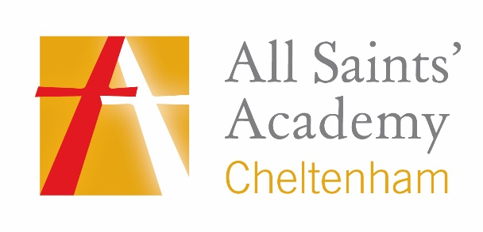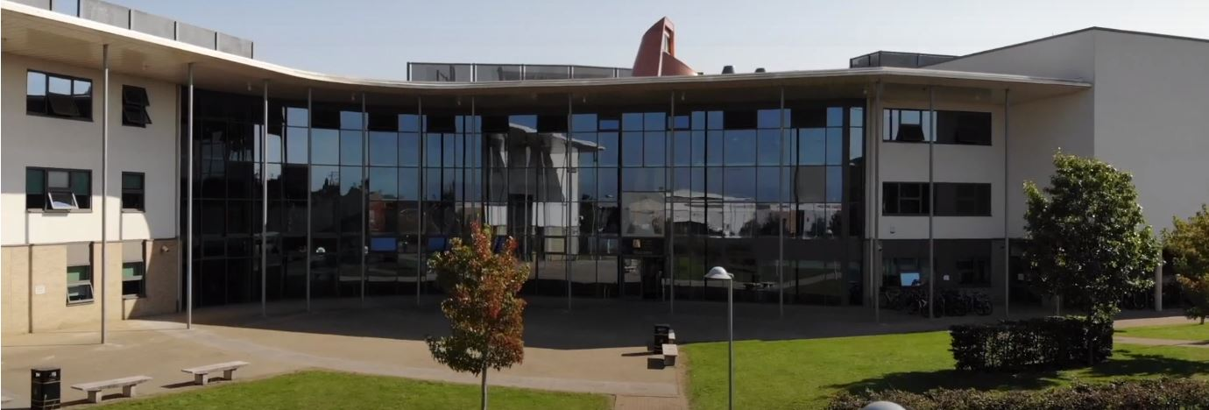
Application Pack
Minibus Driver
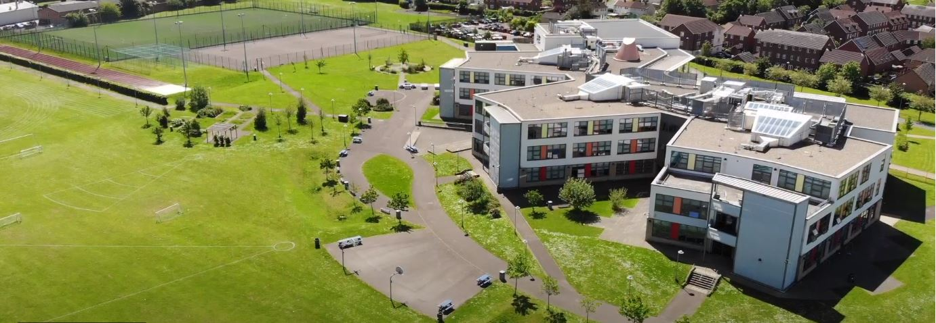
Where every member of our extended family realises their God-given potential, inspired by John 10:10. Jesus said ‘I have come so you may have life in all its fullness’.
2014 2018

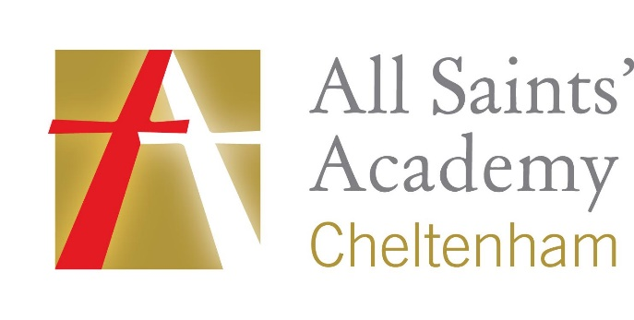
www.asachelt.org

All Saints’ Academy, Cheltenham, Gloucestershire.
Principal: Mr Dermot McNiffe

Minibus Driver
Start date: January 2022
Salary: Grade E Points 4-8 £18,933 - £20,493 pro rata (actual pro-rata salary £8,728 -£9,447 per annum)
Hours of work: 20 hours per week, term time and one week during inset days
Closing date: 9 am Monday 8th November 2021

We are looking for a reliable minibus driver to work on a part time basis to help with collecting students before the academy day starts and dropping them off at the end of the academy day. The hours of work will be 7am – 9am and then 3pm – 5pm.

The ideal candidate will be a minimum of 21 years of age (for Academy insurance reasons), hold a license with category D1 and will demonstrate evidence of driving appropriate vehicles. We are looking for someone who will be able to provide a safe, reliable and courteous service.

All Saints’ Academy is one of the best GCSE performing non-selective secondary schools in the Cheltenham and Tewkesbury area, and it has been for a number of years now.

Following another Good judgement, Ofsted reported:

• All Saints’ Academy is an inclusive school.
• Leaders and directors have been successful in improving pupils’ life chances by ensuring that they have achieved well in recent years.
• Staff hold fast to the school’s values and ethos, which unite them in their drive to improve standards.
• There is a clear determination to support pupils and their families to overcome barriers.
Ofsted 2018

Sponsored by the Anglican Diocese of Gloucester, we are an Academy serving at the heart of our local community. All Saints’ Academy has a Life Vision, ‘Where every member of our extended family realises their God-given potential, inspired by John 10:10. Jesus said 'I have come so you may have life in all its fullness'.

We are an inclusive Church Academy who welcomes applications from all denominations and those of none.

What we offer:
- The Academy is in an attractive new building, within easy access to Cheltenham, Tewkesbury and the M5 with onsite catering facilities
- Entry into the Local Government Pension scheme
- Free access to the onsite gym facility
- Access to our Employee Assistance Scheme
- Free onsite parking

The Academy is committed to safeguarding and promoting the welfare of children and young people, and expects all staff and volunteers to share this commitment. Successful applicants will be subject to enhanced DBS clearance.

To apply for this role please send a covering letter and a completed Support Staff Application Form to Katie Jordan, HR Manager at hr@asachelt.org

Interviews maybe held remotely depending on government guidelines at the time of interview. Full details will be emailed to the shortlisted candidates.

All Saints’ Academy is committed to ensure that all applicants and employees are given equal opportunities and that no applicants or employees are discriminated against on the basis of gender, gender reassignment, race, disability, pregnancy or maternity, sexual orientation, marital or civil partnership status, age or religion and belief.

Job Description

- Post Title: Minibus Driver
- Hours: 20 hours per week/ Term time plus inset days
- Reporting To: Site and Community Manager

Key Activities
- To provide safe and reliable minibus driving for students attending the Academy
- To support students and staff in accessing extra-curricular opportunities if required
- Basic minibus maintenance and cleaning
- To guide pupils to ensure they act responsibly whilst travelling in the mini bus
Post holder requirements
- To have a clean full D1 eligible driving licence to allow minibus driving.
- Will be a minimum age of 21 years to comply with Academy insurance restrictions.
- Will hold a current MIDAS driver training qualification or be willing to undergo the relevant training provided by the Academy.
- Will have a basic knowledge of vehicle maintenance and road safety requirements.
- Will have good communication skills with students and be punctual for all commitments
- Will have a flexible approach to the role
Other specific duties
All support staff will be expected to accept reasonable flexibility in working arrangements and the allocation of duties, in pursuance of raising student achievement and effective team working. Support Staff will also:
- model the ethos and vision for the Academy
- to continue personal professional development as required
- to actively engage in the performance review process
- support whole Academy acts of worship and prayer for the day.
It is important that all staff recognise that they are an integral part of the Academy and have a duty to contribute to its overall effectiveness both within their specific areas and beyond.
Whilst every effort has been made to explain the main duties and responsibilities of the post, each individual task may not be identified. Employees will be expected to comply with any reasonable request from the Principal to undertake work of a similar level that is not specified in this job description and to undertake all duties reasonably requested by their line manager in a manner consistent with the vision of All Saints’ Academy.
The academy will endeavour to make any necessary reasonable adjustments to the job and the working environment to enable access to employment opportunities for disabled job applicants or continued employment for any employee who develops a disabling condition.

PERSON SPECIFICATION

 | Essential | Desirable
Qualifications | - Clean UK driving license  - Category D1 on driving license | - Current MIDAS training  - Safe guarding Training  - First Aid Trained
Skills | - Confident driver  - Show initiative and approach challenges with a positive attitude  - Organised and able to prioritise own workload  - Excellent time keeping | - Previous experience of driving a minibus  - Experience of working with young people
General | - Flexible and enthusiastic attitude  - Clear ability to relate to young people  - A commitment to a positive culture of learning  - Resilience and able to work unattended  - Excellent communication skills  - Willingness to support on Academy trips or other events outside of normal working hours if needed | - Have ideas that you can turn into practice.  - Ability to be part of a team  - Ability to self-review effectively and set appropriate targets  - Willingness to be and Academy First Aider for staff and students

