Microsoft 365 and Teams – How to Login
On any web browser, e.g. Google Chrome, Microsoft Edge, Safari etc, go to www.office.com

Click sign in and sign in with your full school email address and password.
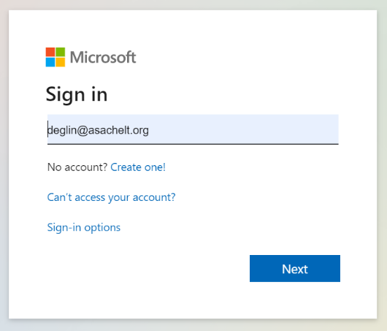
You are now signed into Microsoft Office 365 and can access ‘Lite’ Office Software such as Word, Powerpoint, Teams and OneNote etc.

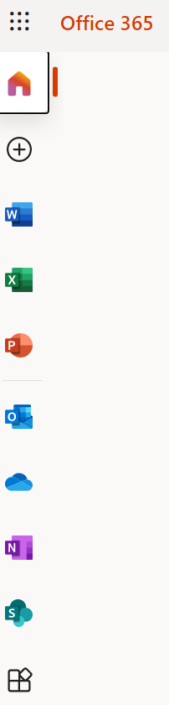
Apps appear on the left had side of the screen. Scroll down to see more or click on ‘All Apps’ to see the full range of Apps.
Scroll down to Teams and click on it.
You should now see all your class Teams that have been setup for you by the IT Department. In each Team your teachers can share teaching resources, message you and also setup virtual online meetings, but more on that later.
You can also download the Teams App to your phone.
Also, many of your teachers will begin to use OneNote as a means of sharing their teaching notes with you so it is highly recommended that you download the OneNote App too.

NOTE: This is organizational level software so everything you do in it can be searched. You must use it respectfully as an effective means for communication with your teachers and classmates.

