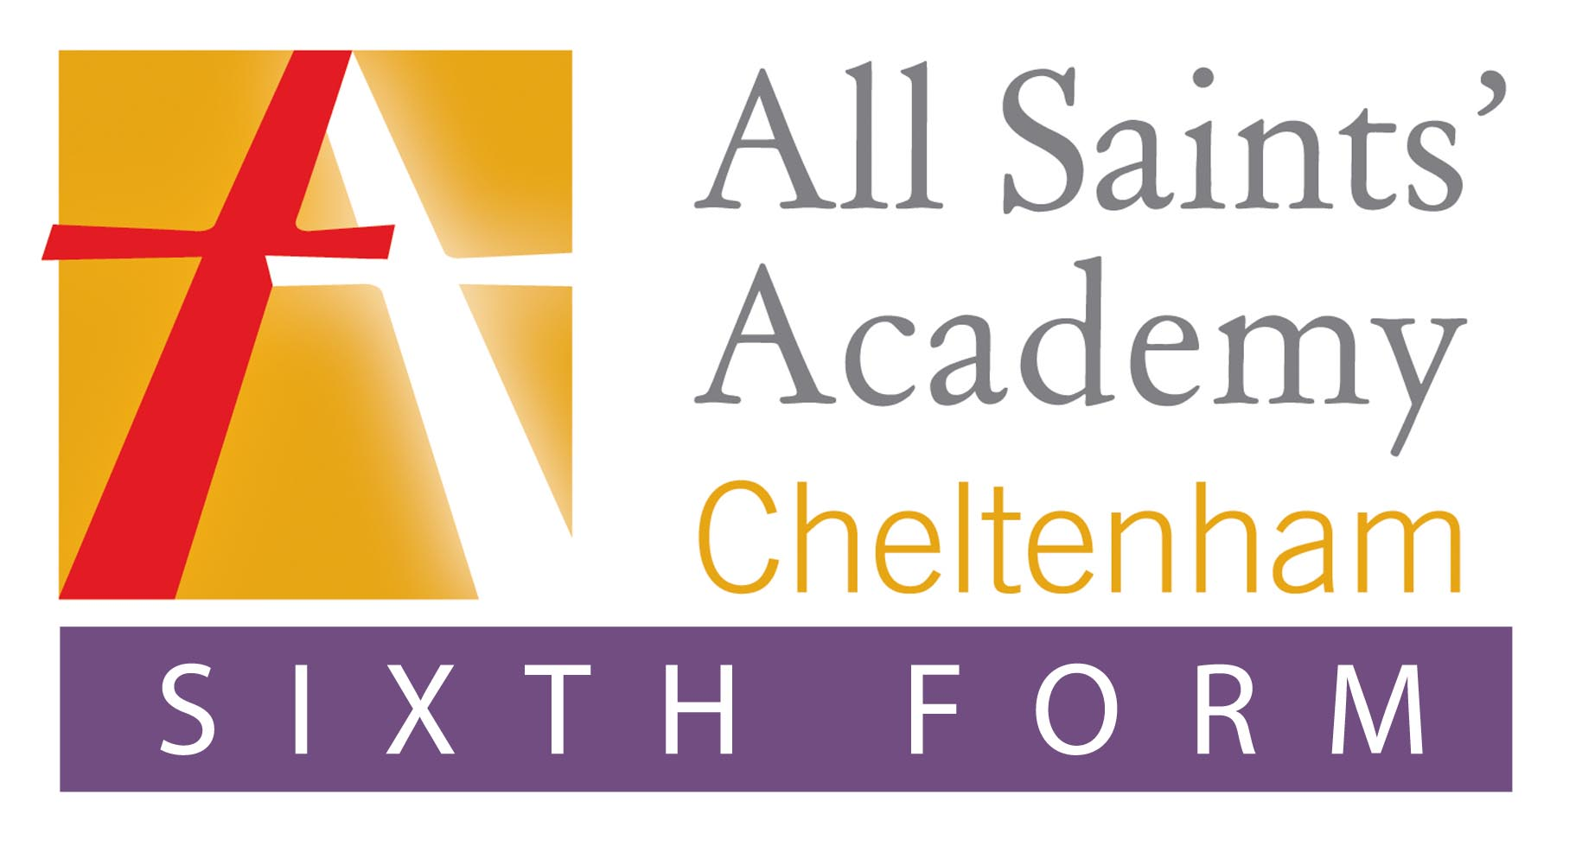

Dear Parent/Carer, **16-19 Bursary Fund 2021 - 2022**

We would like to draw your attention to the bursary fund that is available to students studying at All Saints’ Academy Sixth Form. The bursary supports young people who need some financial assistance to help them stay in education in the Sixth Form.

All Saints’ Academy has been given a fixed sum of money from the Education and Skills Funding Agency to support students in this way. As it is a fixed sum, it may not be possible to award a bursary to every student who applies. Support for students will be prioritised on the following criteria:

**Priority group 1: for those in defined vulnerable groups**

Guaranteed bursaries of up to £1,200 payable to those students who are:

1. in care (as defined by social services), Leaving or have recently left care.

2. Are in receipt of Income Support or Universal Credit in their own right. (Student must also provide additional documentation to confirm their independent status, for example a tenancy agreement in their name.)

3. Disabled and in receipt of both Employment Support Allowance or Universal Credit and Disability Living Allowance or Personal Independence Payments.

**Priority group 2**: **Discretionary Bursary**

A bursary for young people in receipt of free school meals (FSM) subject to punctuality and meeting 96% attendance criteria weekly. We would encourage all Sixth Formers who are entitled to FSM to apply and then take up this opportunity. FSM forms can be downloaded from our website.

Eligible students in group 2 may apply to the Bursary Fund for a contribution towards items such as the cost of school transport, essential course equipment, trips and course materials. This may be a one off payment for a specific item.

We do also acknowledge that some parents/students find themselves unable to access FSM as families are in receipt of tax credits or equivalent. In the event of funds remaining within the academy’s Bursary Fund allocation, once all Priority 1 and 2 awards have been made, awards can be made to students of families with a low household income.

You must provide clear evidence of your household income level. Examples may include; Universal Credit statements, P60, Tax Credit Award Notice or evidence of self-employed earnings, Income Support information, Inland Revenue Form beginning TC60. (All Bursary support will be dependent upon meeting attendance, punctuality, behaviour and academic attainment)

Information about the 16 – 19 Bursary, our policy for assessing and allocating funding and the application form can be found on our website.   
  
Yours sincerely,

Mrs C Cain

Head of Sixth form

Principal: Dermot McNiffe, BA Hons, NPQH

All Saints’ Academy,

Blaisdon Way,

Cheltenham,

GL51 0WH

Tel: 01242 711200

Email: [admin@asachelt.org](mailto:admin@asachelt.org)

www.asachelt.org