1st March 2021

Dear Parents and Carers,

I hope that you are keeping well and safe at this time.

I am writing to inform you of our plans and preparations for the opening of All Saints’ Academy to all of our students for the week beginning Monday 8th March.

For your information, I have included the link to the most up to date government Coronavirus information for parents below:

<https://www.gov.uk/government/publications/what-parents-and-carers-need-to-know-about-early-years-providers-schools-and-colleges-during-the-coronavirus-covid-19-outbreak/what-parents-need-to-know-about-early-years-providers-schools-and-colleges-during-covid-19>

To help schools prepare and to ensure that students can start in school as soon as possible, both the Department for Education and the Local Authority have advised that schools may prepare for opening before the 8th March to allow for Lateral Flow (LFD) Coronavirus testing.

Therefore, we want to invite our Year 11 and Year 13 students on Friday 5th March for their first test so that they are ready to start full onsite education on Monday 8th March. The table below indicates the timings for each tutor group to be at the Academy ready for testing. Please refer to the place for arrival, arriving 5 minutes before the allocated time where students will be greeted by their tutor and staff:

**Year 11 & Year 13 Friday 5th March 2021**

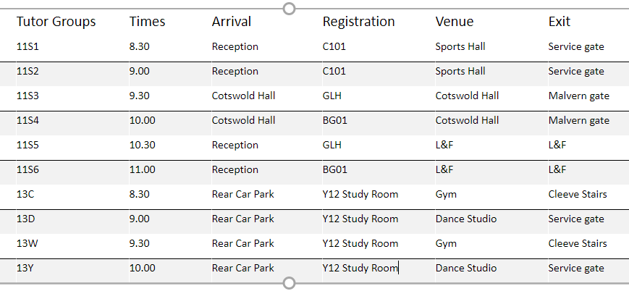

May I take this opportunity to reassure you that testing is now a common occurrence in the Academy and has been since the beginning of January. We have fully trained staff to support testing and there have been no concerns with regards to students or staff performing tests since January. However, should you require any further information or guidance on LFD testing please contact 01242 711200.

The remaining year groups will be invited into the Academy to take their initial tests over Monday, Tuesday and Wednesday. The aim is to have all students tested by the end of Wednesday 10th March.

The second and third subsequent tests will be done during the normal running of the Academy day, which will take place 4 or 5 days after the first initial test.

**Year 10 & Year 12 Monday 8th March 2021**

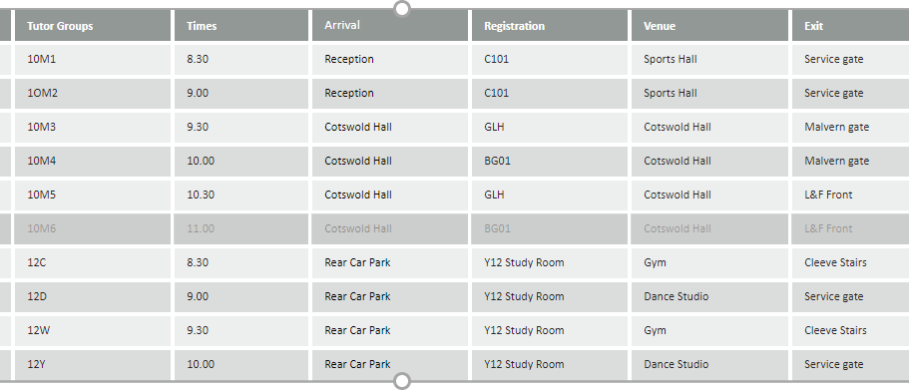

Year 10 and Year 12 Students will then be ready to start full onsite education on Tuesday 9th March.

**Year 8 & Year 7 Tuesday 9th March 2021**

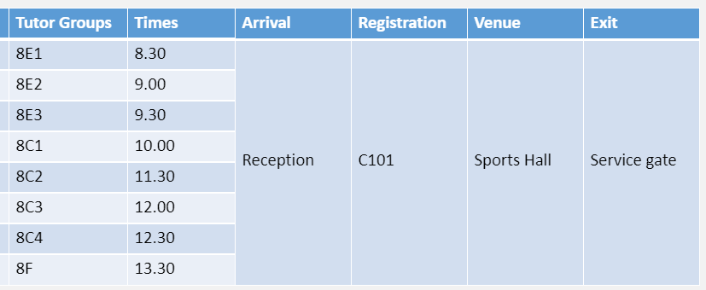

Year 8 Students will then be ready to start full onsite education on Wednesday 10th March.

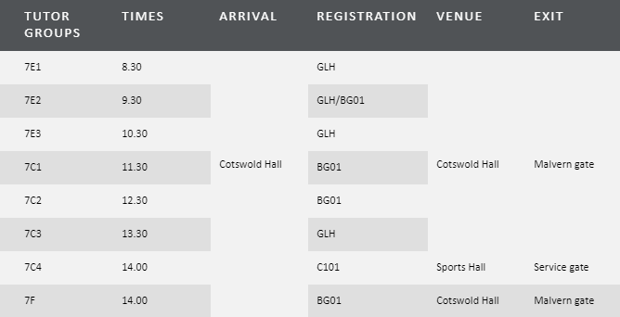

Year 7 Students will then be ready to start full onsite education on Wednesday 10th March.

**Year 9 Wednesday 10th March 2021**

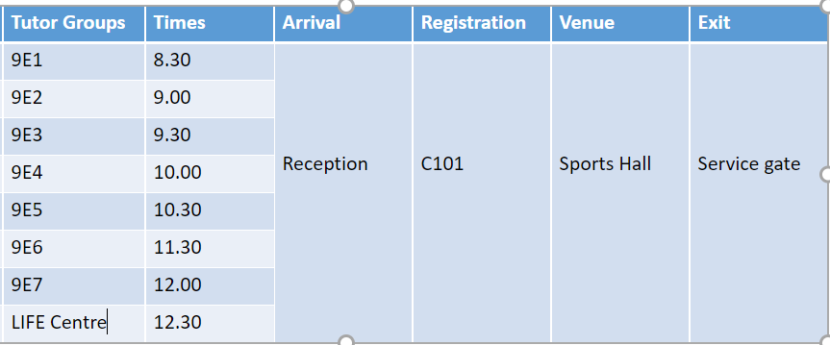

Year 9 students will then be ready to start full onsite education on Thursday 11th March

For all year groups, students will return home after they have completed their first test to continue with remote learning. They will then start back in the Academy the day after they completed their test.

Consent for testing

Prior to testing students we are required to obtain consent. For students under the age of 16, a parent/carer will need to complete the form. For students 16 and over they may complete the form themselves. Please find the link for this below:

*Please note: If you have already completed the form prior to our start of term in January, then you do* ***not*** *need to complete this again.*

<https://forms.office.com/Pages/ResponsePage.aspx?id=qY8lnIlcgkCxPB8yoMDuG4-xIu1B8c9AsMvy-fiDK9dUOE0zSTUzNkJOVkg5NldaODQ2NFdOQUI3TC4u>

**May I remind you that should the following occur please do not send your child to school:**

* They are showing coronavirus (COVID-19) symptoms**:**

• a new continuous cough  
• a high temperature  
• a loss of, or change in, your normal sense of taste or smell (anosmia)

* Someone in their household is showing symptoms.

**Transport**

Just to confirm that all school transport will be operating in full from 8th March.

1. **Face coverings:** Secondary school students must wear face coverings on all school transport and public transport, this includes any students that are brought to school by taxi/minibus
2. **Waiting at the bus stop:** Students need to social distance from each other whilst waiting at bus stops, only students from the same household or year group should stand together.  Like many of the above measures we are dependent on students taking responsibility for this themselves and being sensible.

More information will follow when available. If you have any questions or queries please do not hesitate to contact the Academy.

Yours sincerely



Mr D McNiffe

Principal