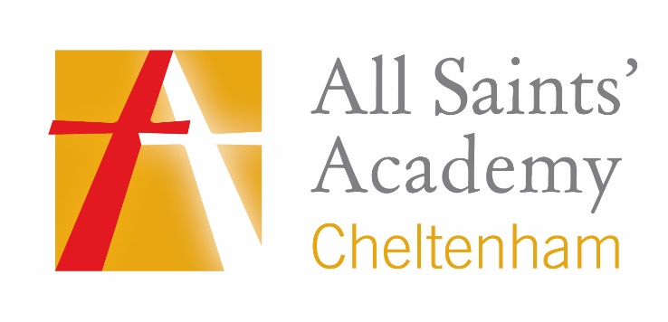
Careers resources
What career would suit me?
Career coach – assessment to help you understand what areas of work may suit you
https://gfirstlep.emsicc.com/?radius=&region=Gloucestershire

General career resource
Glos Lift Off – videos and range of info (includes: traineeship, business support, apprenticeships, higher education)
https://www.glosliftoff.co.uk/videos

SACU – student
https://sacu-student.com/

Inspiring girls
Interview with Kirsty Lewis – female Red Arrows pilot
https://gfirstlep.emsicc.com/?radius=&region=Gloucestershire

Circle2 success – international women’s day
https://www.youtube.com/watch?v=-Q3JKzYjBOY

Apprenticeships

ASK program – Amazing Apprenticeships
https://amazingapprenticeships.com/resources/
Career finder – UCAS apprenticeships
https://careerfinder.ucas.com/jobs/apprenticeship/

Advice for interviews, CVs, recruitment
Hooray recruitment videos
https://www.youtube.com/channel/UCJGrMqOyFvXjX5lLnMFvzQA/null
Richard Graham – MP Gloucester
https://www.richardgraham.org/useful-information-job-hunting

Career-specific

Hazelwoods
https://www.hazlewoods.co.uk/careers
St James Place – Wealth management
https://www.sjp.co.uk/careers
Bae systems
https://www.baesystems.com/en/careers
GCHQ
https://www.gchq-careers.co.uk/index.html
Superdry
https://careers.superdry.com/head-officeVi
Sky News – making the news
https://drive.google.com/file/d/1_q7dV_8U8y42VdBou70CMlQdWJWrzX9R/view

Career pilot resources
Year 7:
https://careerpilot.org.uk/adviser-zone/key-stage-3-resources-and-presentations/year-7-resources

Year 8:
https://careerpilot.org.uk/adviser-zone/key-stage-3-resources-and-presentations/year-8-resources

Year 9:
https://www.careerpilot.org.uk/adviser-zone/key-stage-3-resources-and-presentations/delivering-careerpilot-in-pshe-year-9-scheme-of-work

Year 10:
https://www.careerpilot.org.uk/adviser-zone/key-stage-4-resources-and-presentations/year-10-resources

Year 11:
https://www.careerpilot.org.uk/adviser-zone/key-stage-4-resources-and-presentations/year-11-resources

